Eproject

E-Project for Semester 1

---

Cera Tiles website

---

|  |  |
| --- | --- |
| **Authors** | **Aptech – C2304L2 - Group : 03** |
| 1. HUONG NGUYEN THI DIEM - Student1465592 [(Leader)] 2. QUAN TRUONG MINH - Student1470049 |
| **Centre Name** | Aprotrain Aptech |
| **Date** | 21 MARCH, 2024 |
| Course | ACCP |
| Curriculum Code | OV-7091-ADSE |
| **Semester** | Semester 1 |
| **Instructor** | TRI PHAN HUU |

**Ho Chi Minh City, 21/03/2024**

**TABLE OF CONTENTS**

Clearly organized list of document sections and subsections

1. **Introduce eProject – Project name:** 4
2. Problem definition of project 4
3. List of Inputs to the Website 4
4. List of Outputs Expected from the Website 5
5. Overview of Processes Involved in the Website 5
6. Hardware and Software Required for Implementing the Project 6
7. Flow chart 6
8. Table assigning tasks to members (Leader) 8
9. **Instruction to run the project** 10
   1. Import database and tables into MySQL 10
   2. Import Project into Visual Studio Code 11
   3. Run Web Application (Web Admin): 13
10. *Login 13*
11. *Manage company information and geolocation 14*
12. *Manage Role 15*
13. *Manage employee 16*
14. *Manage category 17*
15. *Manage sub category 18*
16. *Manage product 19*
17. *Manage delivery fee 20*
18. *Manage voucher 21*
19. *See transaction 22*
20. *Manage E-catalogue type 23*
21. *Manage E-catalogue Files 24*
22. *Manage Blog category 25*
23. *Manage blog article 26*
24. *Manage contact me request 28*
25. *Dashboard 29*
    1. Run Web Application (Web User): 29
26. *Home Page 29*
27. *Login 30*
28. *Product List 30*
29. *Product Details 31*
30. *Product Comparison 31*
31. *Shopping cart 32*
32. *Checkout 32*
33. *Blog 34*
34. *E-catalogue 35*
35. *Contact 35*
    1. Database 29
36. *ER Diagram 36*
37. *Detail of Tables 37*
    1. Contributions 46

**INTRODUCE EPROJECT – PROJECT NAME**

* + - 1. **Problem definition of project:**

We are tasked with creating an ecommerce website for Cera, a tiles company, which must include the following functions:

+ The Home Page

+ The site should display a menu containing the following categories: Wall tiles, Floor tiles, Special tiles, each with their respective submenu.

+ An e-catalogue available for download, including Glazed Vitrified Tiles, Ceramic Tiles, and Polished Vitrified Tiles.

+ Product details page

+ Compare products page

+ Blog section

+ Contact us page

* + - 1. **List of Inputs to the Website:**
* Admin:
* Authentication: Login/forgot password/change password/ account locked (over login fail attempts)
* Authorization:

+ Create/update/delete roles

+Assign function to role

+Assign role to user

* Create/update company information with geolocation
* Catalogue: CRUD e-catalogue category and e-catalogue file
* Manage contact us request
* CRUD delivery fee and voucher
* Manage blog categories, blog articles and blog comments
* See transactions
* User:
* Authentication:

+Create account, forgot password, change password

+Socialite login: Facebook and google

* E-catalogue download
* See company information and send contact request
* Blog, leave comment
* Shopping cart
* Product comparison
* Payment: PayPal
* Payment history
  + - 1. **List of Outputs Expected from the Website**
* Admin:
* User:
  + - 1. **Overview of Processes Involved in the Website**
* Manage accounts (User and admin)
* Manage products
* Manage company information and request contact
* Authentication/Authorization
* Manage blog
* Manage fee and voucher
* Manage e-catalogue
  + - 1. **Hardware and Software Required for Implementing the Project**
* Hardware:
* 4 cores CPU, 8GB Ram or higher, 120GB storage or higher
* Software:
* Laravel Framework
* Visual Studio Code
* XAMPP
  + - 1. **Flow chart of User**
* Admin:

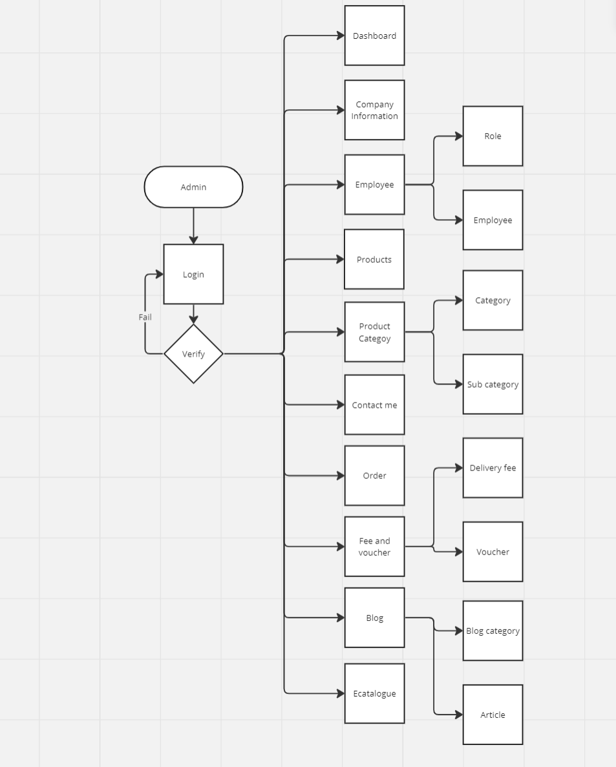

* User:

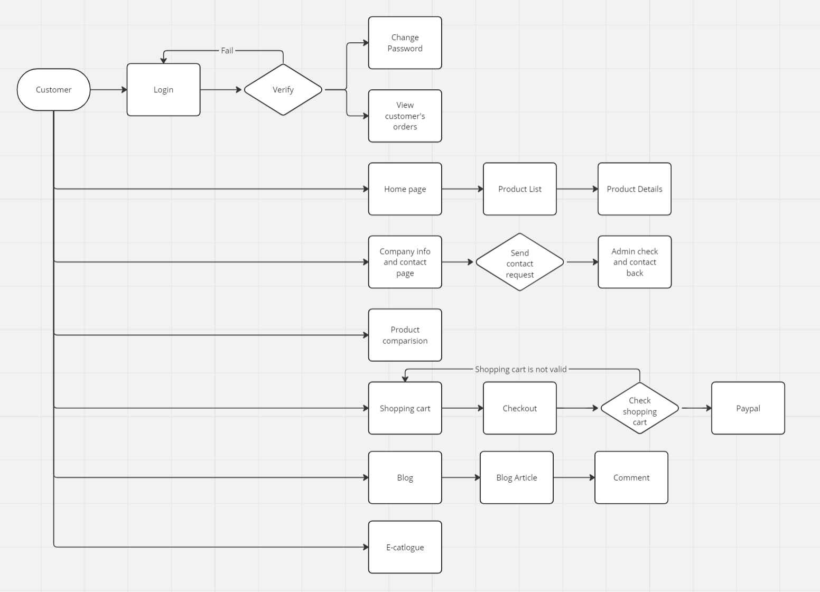

* 1. **Table assigning tasks to members (for Leader)**

|  |  |  |  |  |  |  |
| --- | --- | --- | --- | --- | --- | --- |
|  | **Function** | **Function Details** | **Description** | **Recipient** | **Status** | **Supporter** |
| Database | Database setup | Create database (mysql) | Analyze requirements, design and create database | Quan | Done | **Mr. Phan Huu Tri** |
| Application  (Admin) | Login | -Login using email and password  -Lock account after 5 fail attemps  -Forgot password |  | Quan | Done |
| Role | -CRUD role  -Assign function to role |  | Quan | Done |
| Employee | -Create/Update/Delete employee |  | Quan | Done |
| Product | -CRUD product category/ sub categories  -CRUD products |  | Huong | Done |
| Bog | -CRUD blog categories  -CRUD blog articles |  | Quan | Done |
| About and contact me | -CRUD company information  -Contact me requests |  | Huong | Done |
| E-catalogue | -CRUD e-catalogue types  -CRUD e-catalogue files |  | Huong | Done |
| Voucher | -CRUD vouchers |  | Quan | Done |
| Delivery fee | -CRUD delivery fees |  | Quan | Done |
| Transaction | -See transactions |  | Quan | Done |
| Dashboard |  |  | Quan | Done |
| Application  (User) | Login | -Registration  -Login using registered account  -Login using Google or Facebook account  -Forgot password |  | Quan | Done |
| Product | -Product list with fiter  -Product review |  | Huong | Done |
|  | -Product comparision |  | Quan | Done |
| Cart | -Shopping cart  -Checkout page  -Payment with paypal |  | Quan | Done |
| Contact page | -Display company information and contact me form |  | Huong | Done |
| Blog | -Blog page with search  -Blog detail and comments |  | Quan | Done |
| Ecatalog | -Download E-catalogue page |  | Quan | Done |
| My account page | -Change password  -See transaction history  -Logout |  | Huong | Done |
| Testing |  |  |  | Huong | Done |

**INSTRUCTION TO RUN THE PROJECT**

1. **Import database and tables into MySQL**

* Please open the **cera_database.sql** file that was included with this project



* Open MySQL Admin, click on **'New'**, enter **'care_database'**, and then click **'Create'**

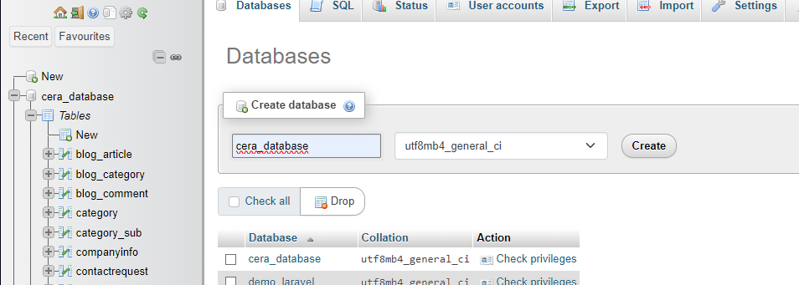

* Open **cera_database** and click on tab SQL

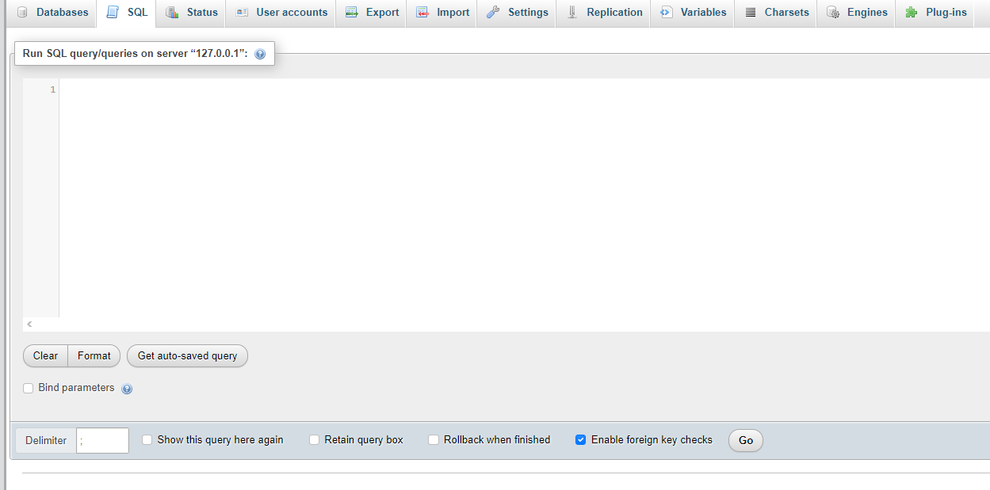

* Copy the code from the cera_database.sql file and paste it into the MySQL admin interface, then click 'Go'. If MySQL returns the message, your database has been created

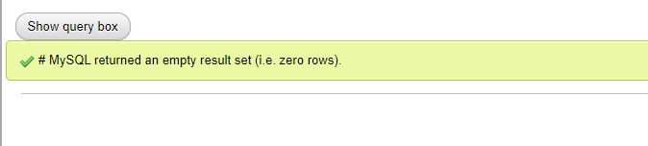

1. **Import Project into Visual Studio Code**

* Open **Visual Studio Code**, click on **'File'**, and then select **'Open Folder'**

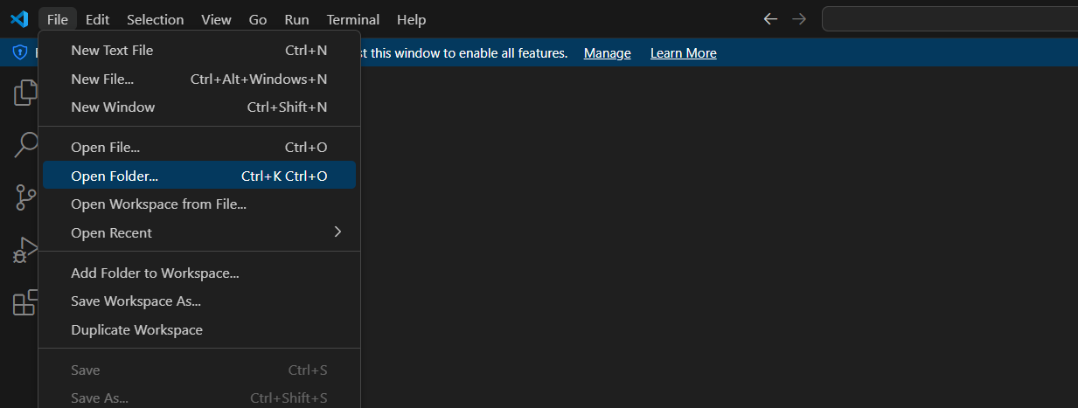

* Navigate to the folder named **'C2304L2._Group03._Cera'** and then click on **'Select Folder'**

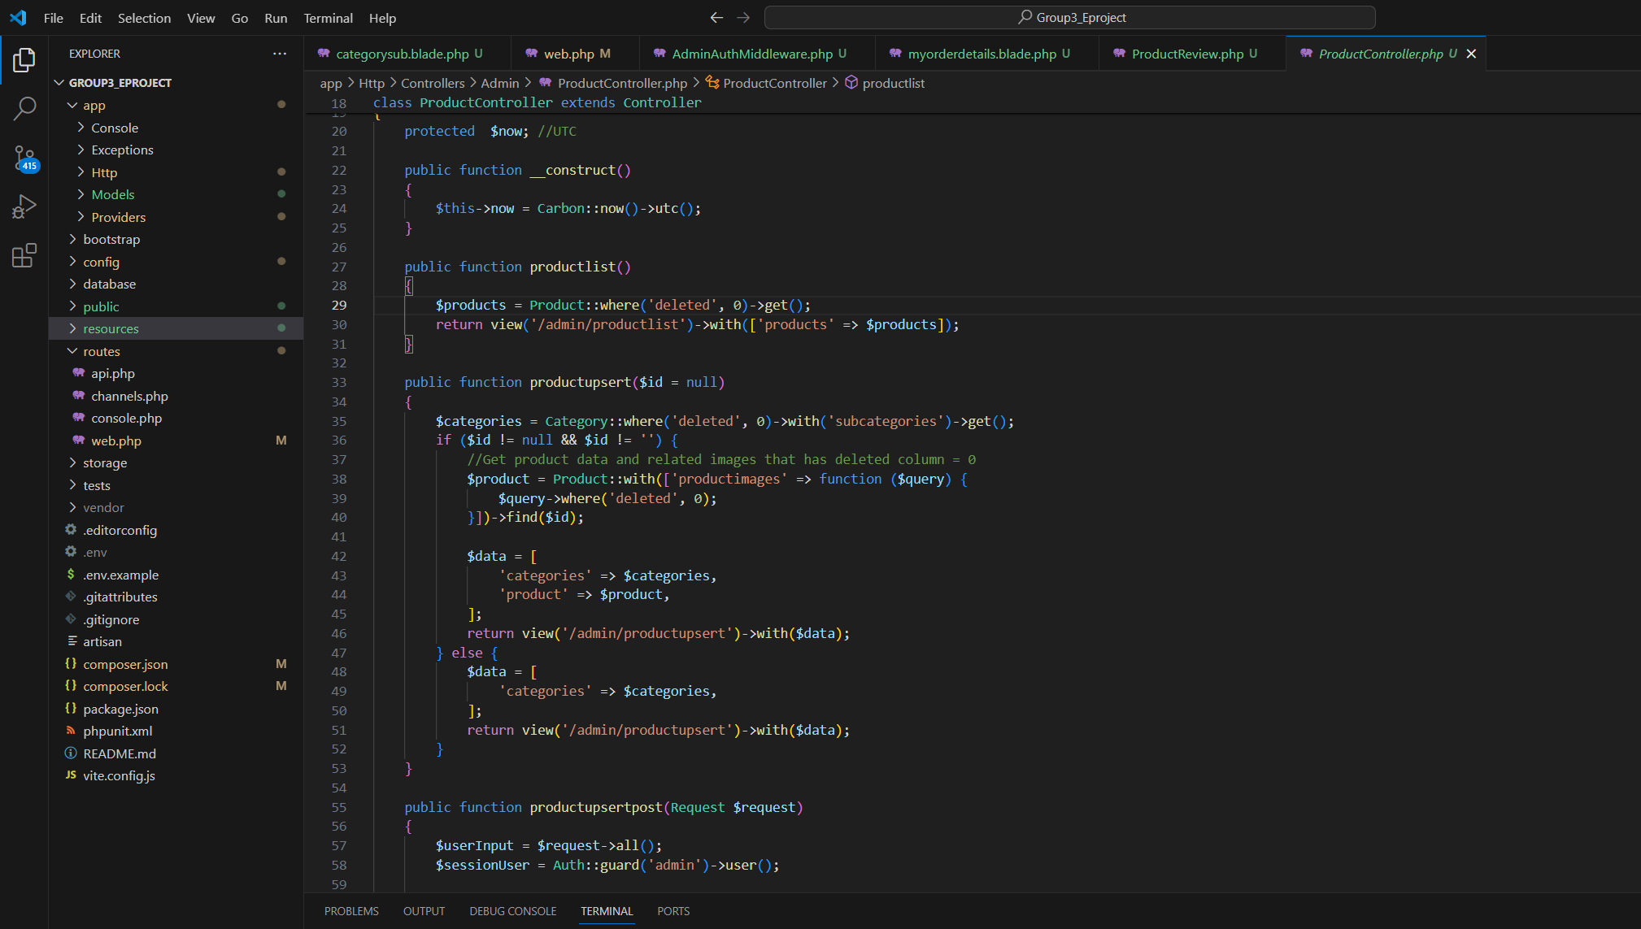

Open file **.env** and change update information:

* Change database connection information

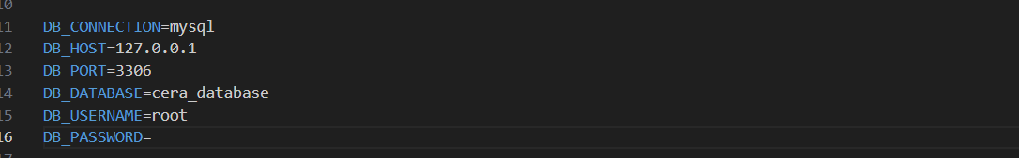

* Update the email service provider information

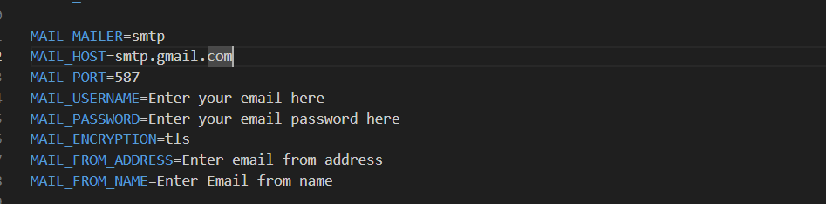

* Update the **PayPal client ID** and **Secret ID**

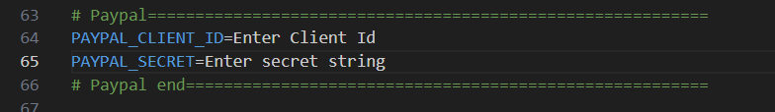

* Update the **Facebook** and **Google client IDs, Secret IDs**, and **return URLs**

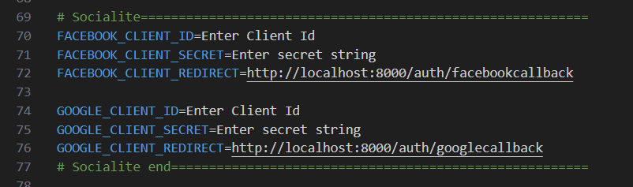

1. **Run Web Application (Web Admin):**
2. Login

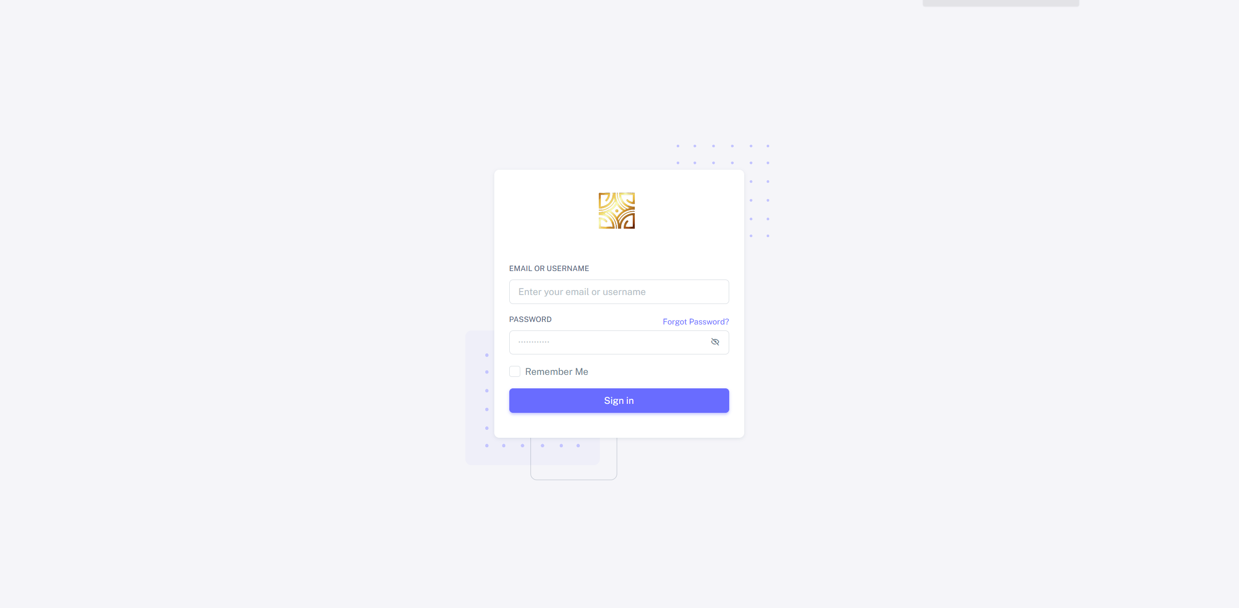

If you forgot password, you can create on Forgot Password?

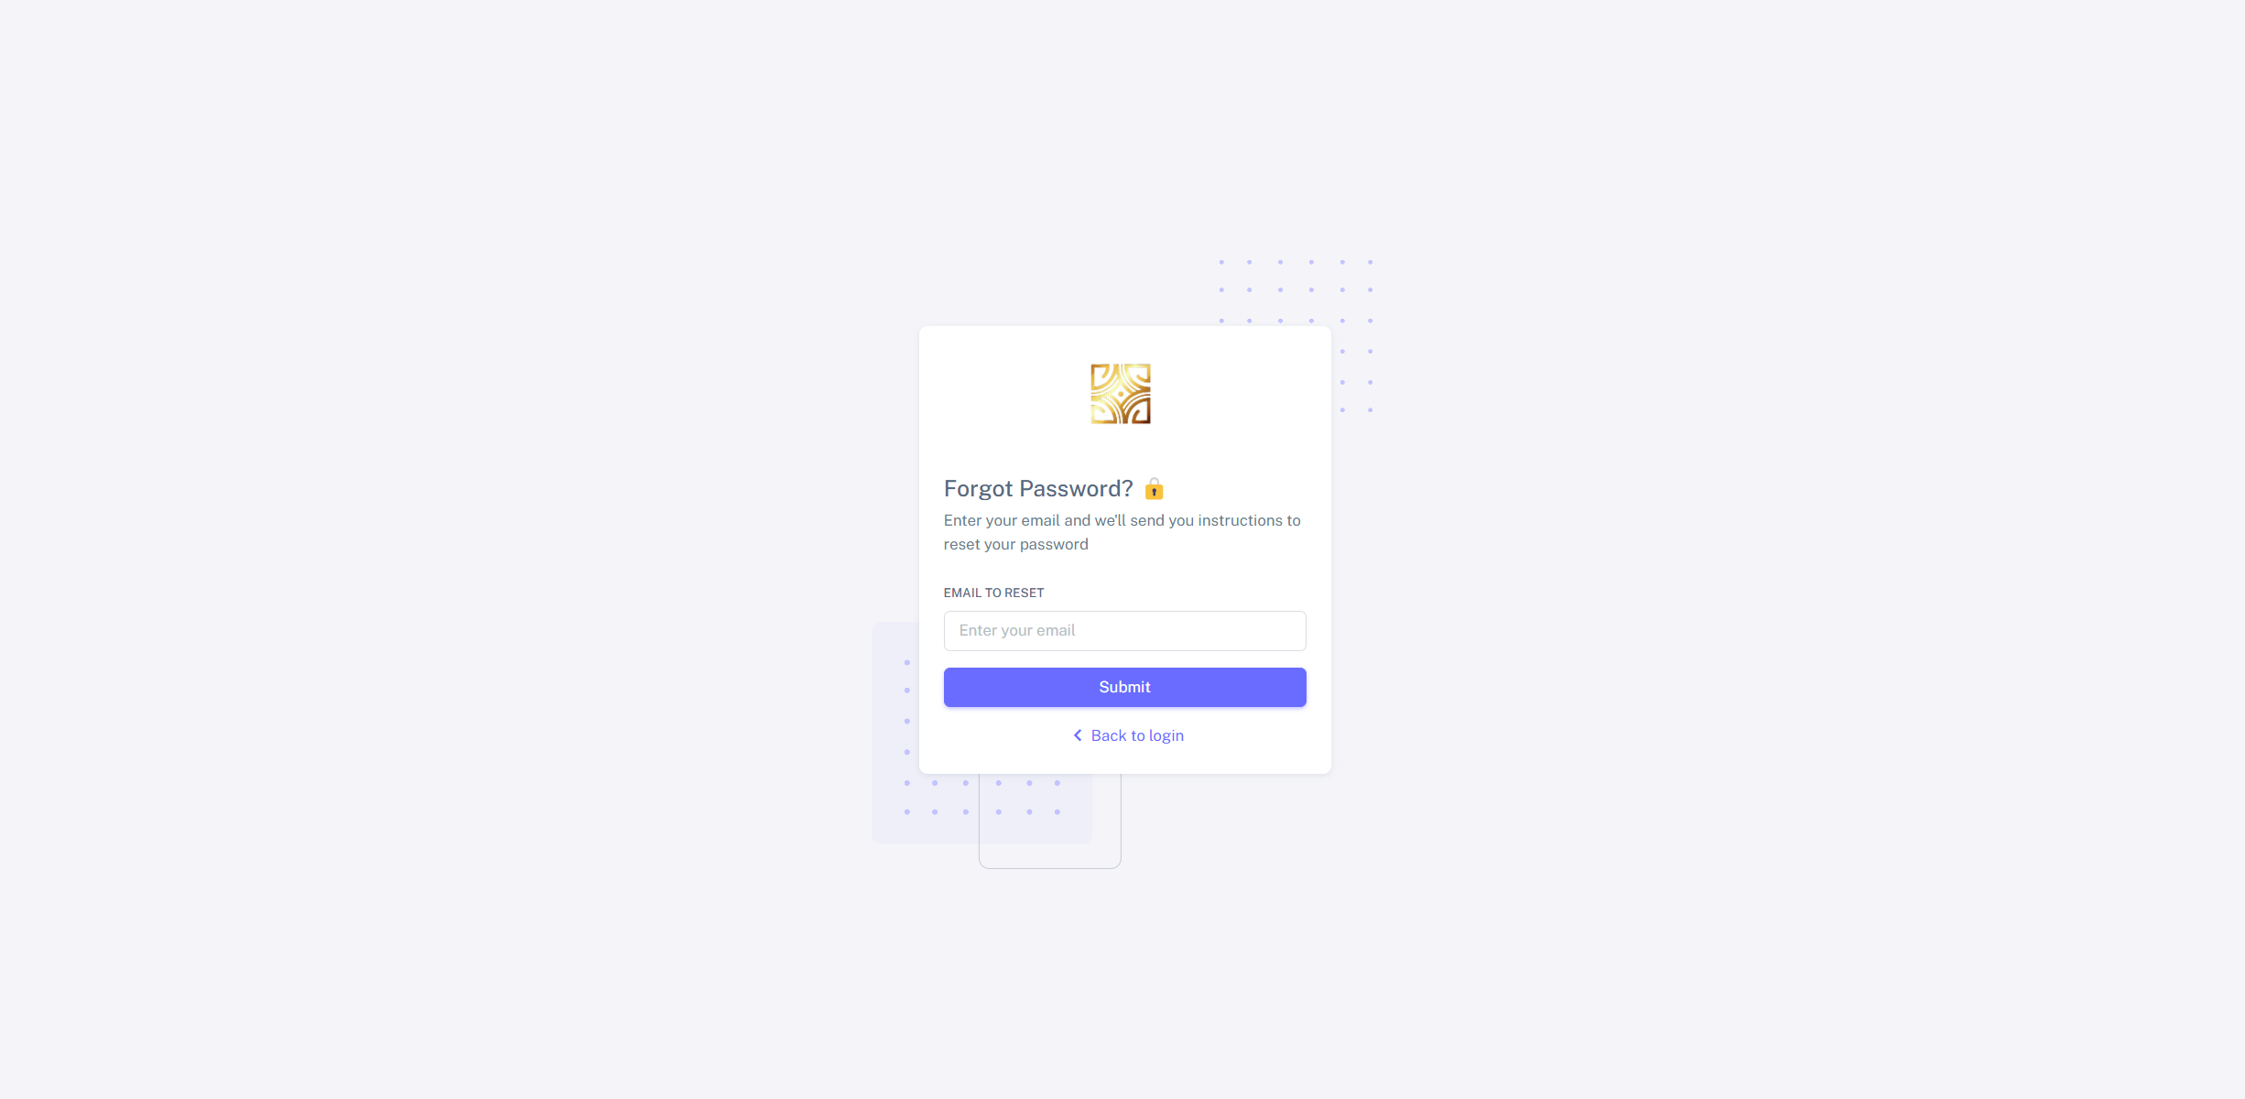

You will receive an email that has reset password link

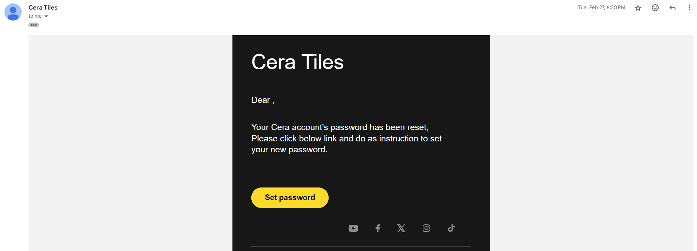

1. Manage company information and geolocation

This information will appear in Contact Page

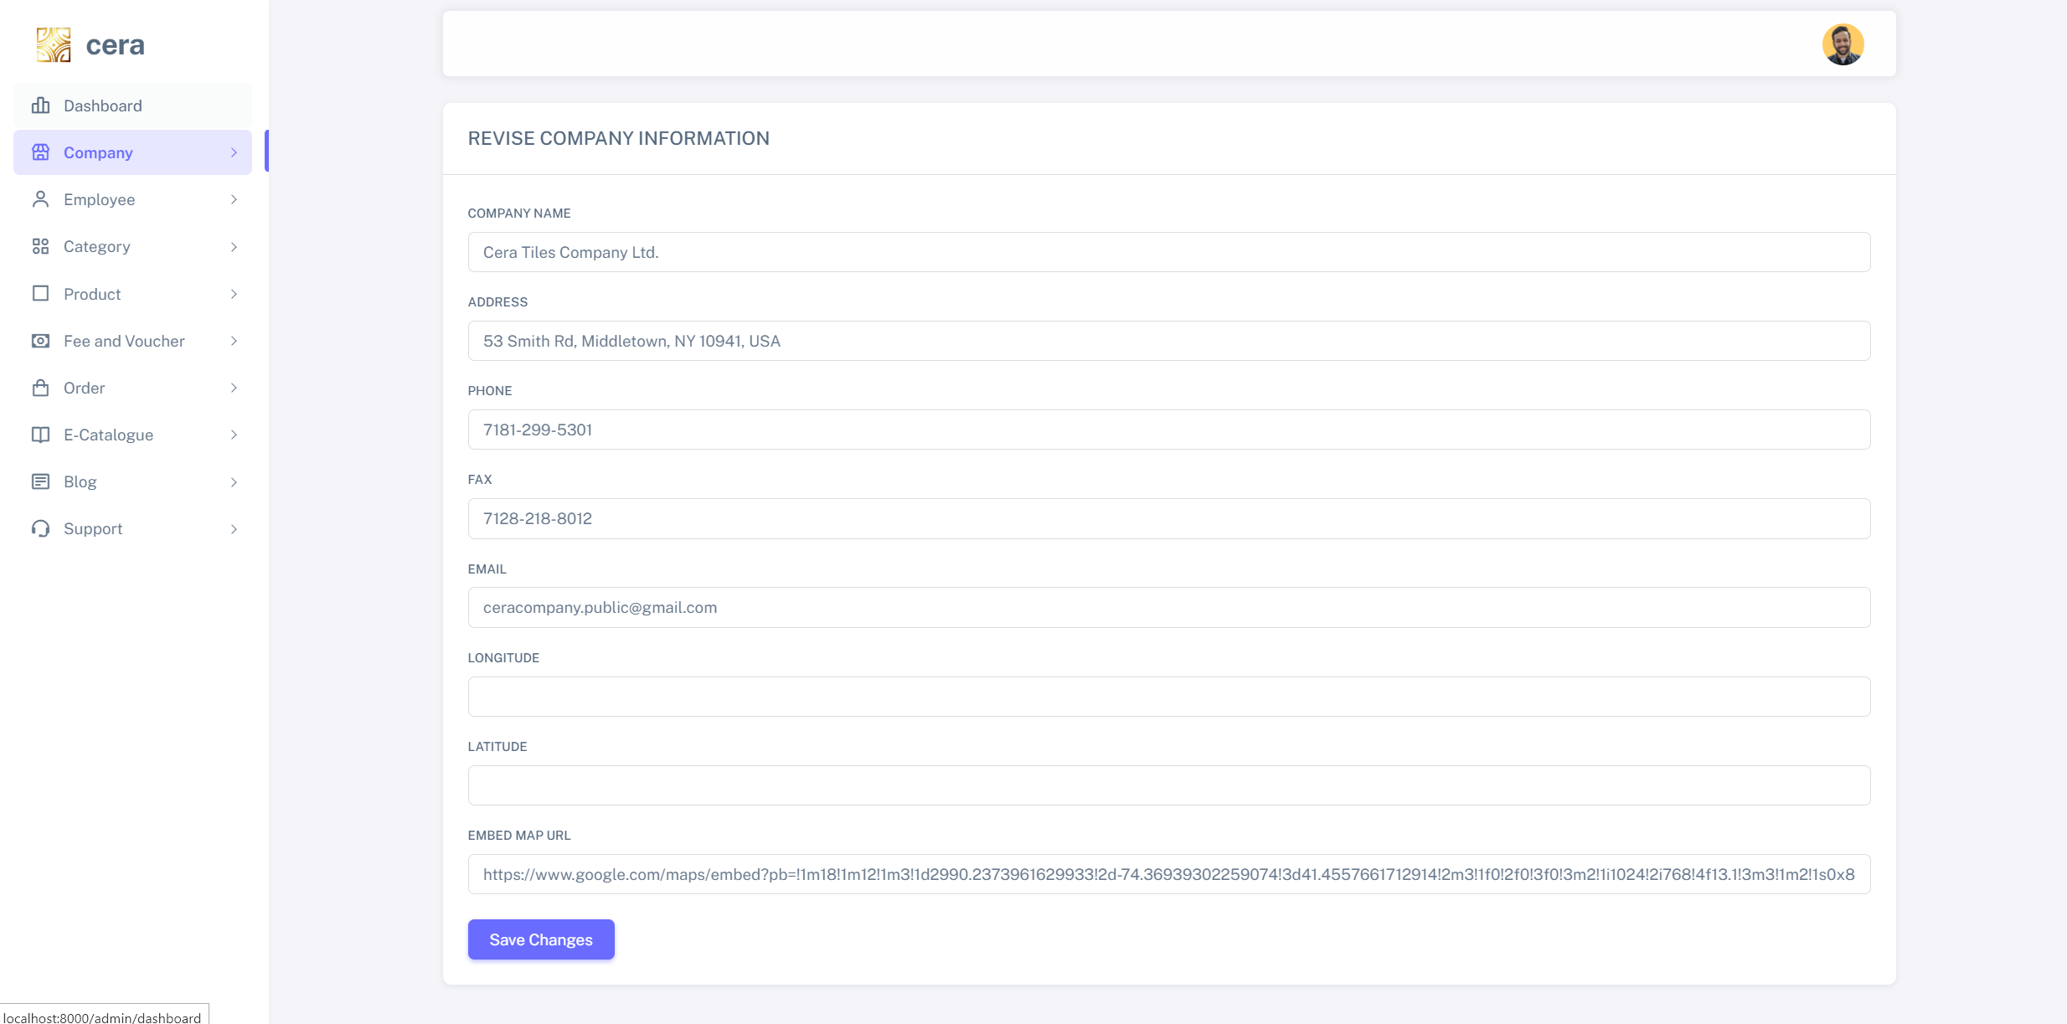

1. Manage Role

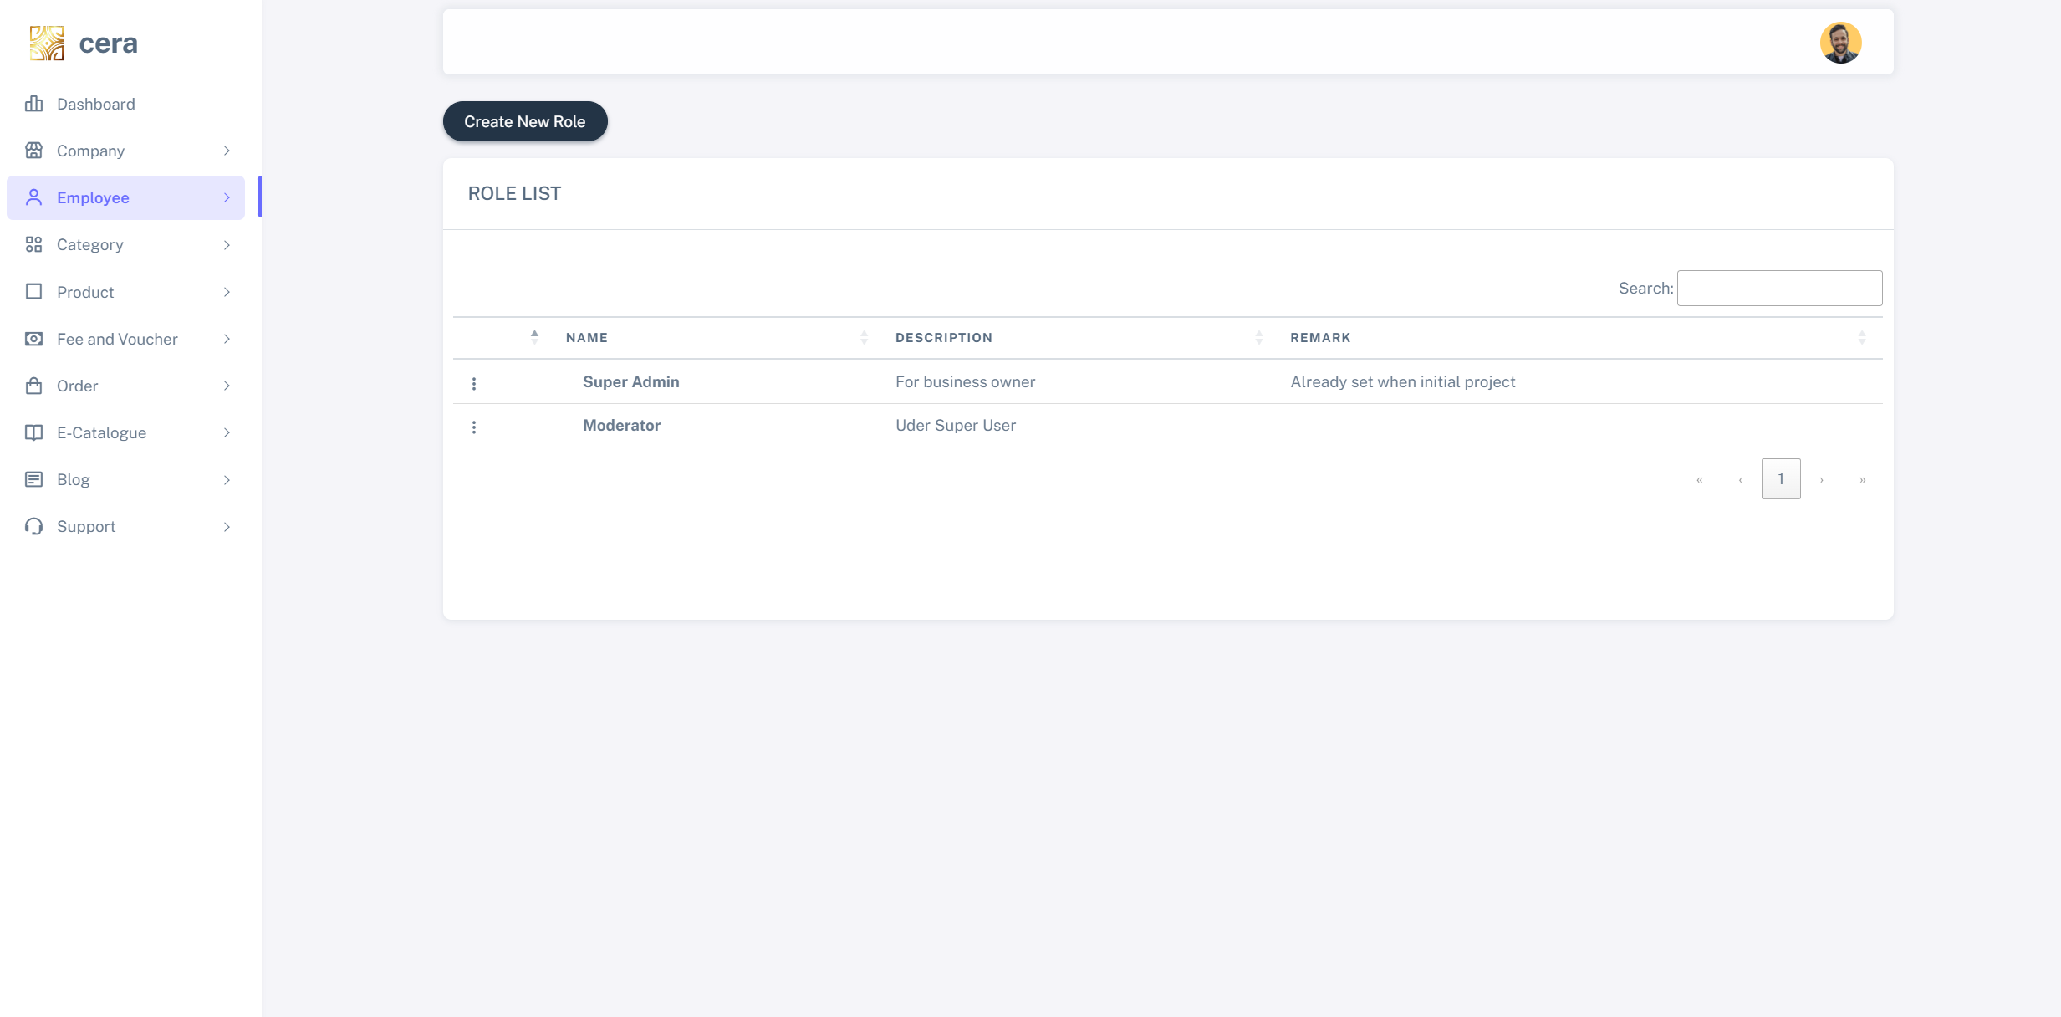

For each role, you can click on three dots to assign function for role

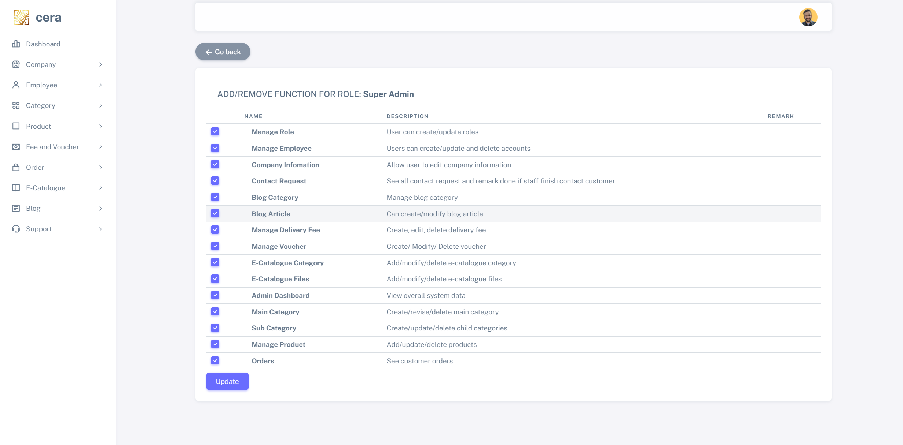

1. Manage employee

Click on Create New Employee

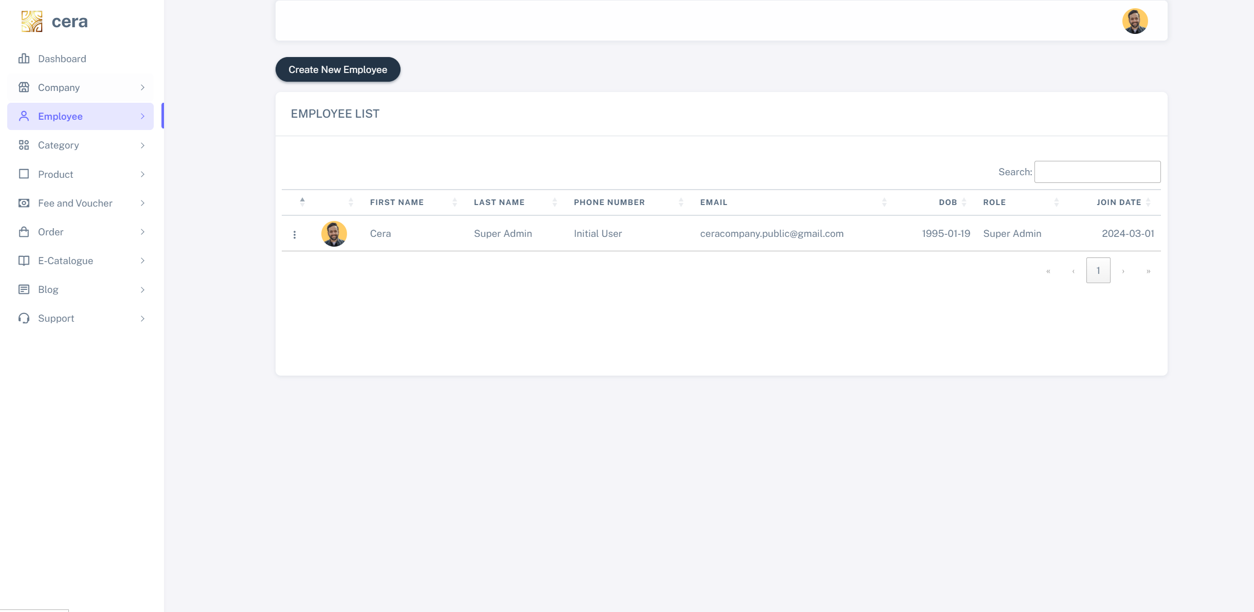

Enter required information, please be notice that for employee, you need to upload profile picture

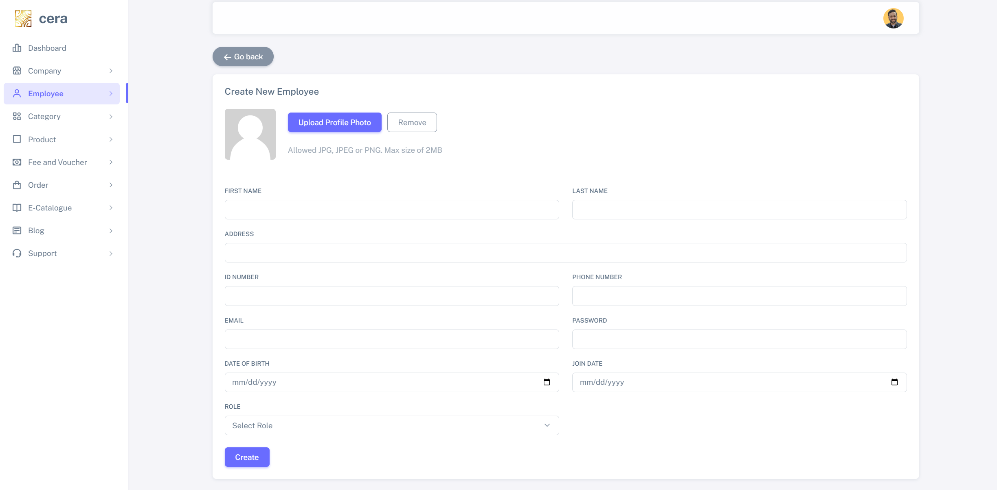

1. Manage category

Create on Create New Main category to create new category or click on three dots icon to edit or delete

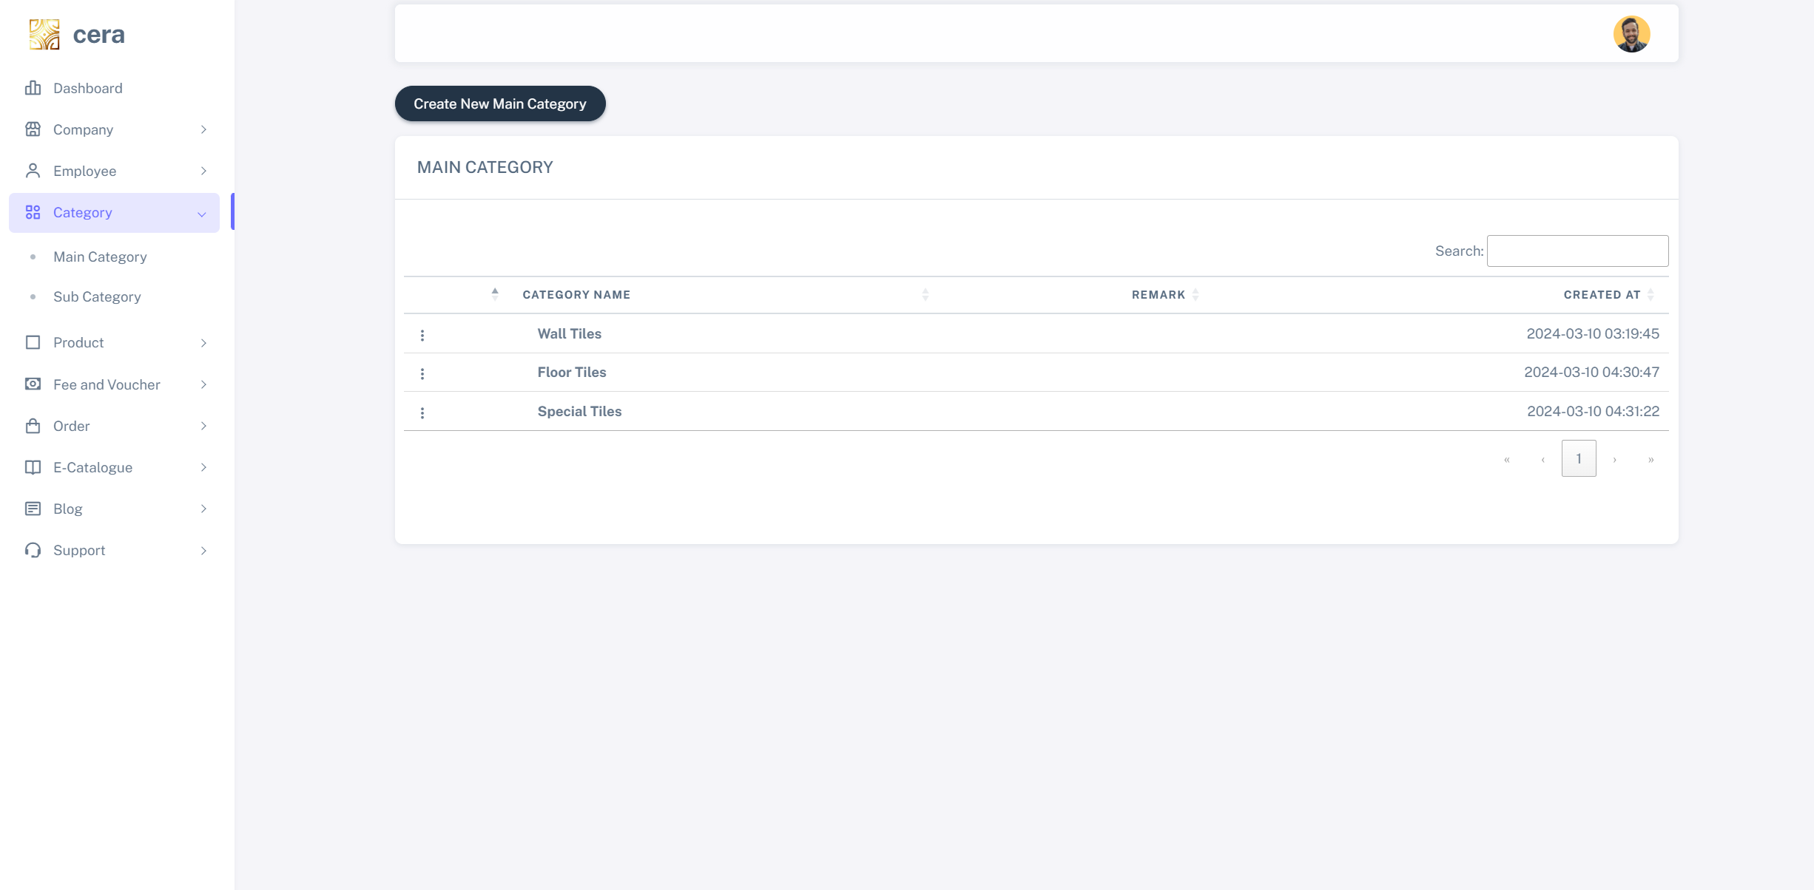

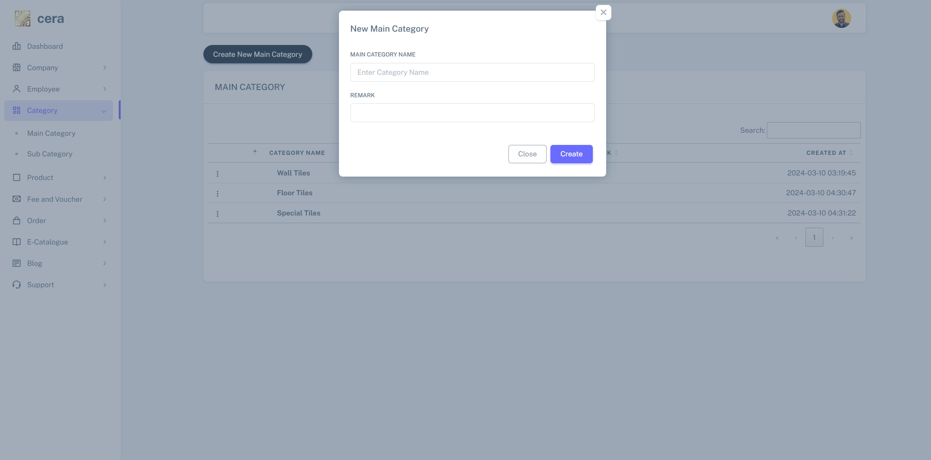

1. Manage sub category

Create on Create Sub category to create new category or click on three dots icon to edit or delete

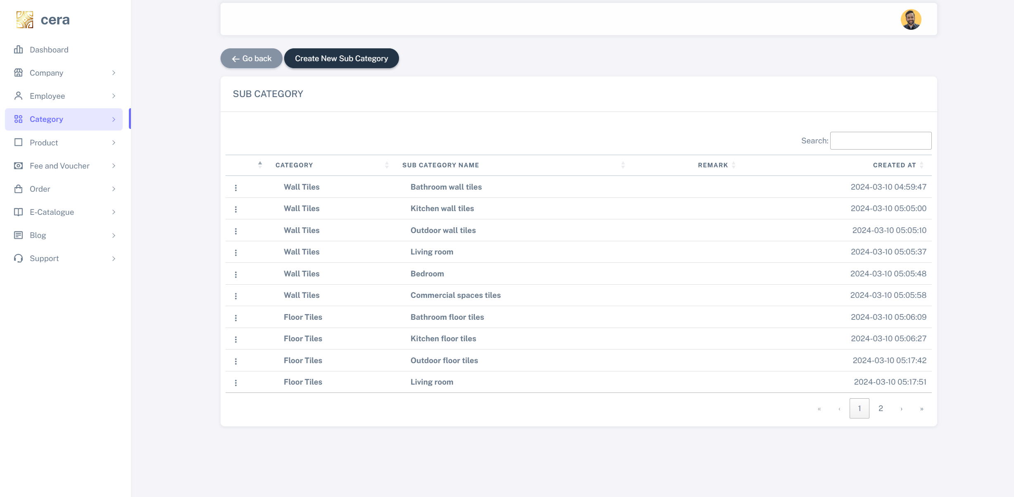

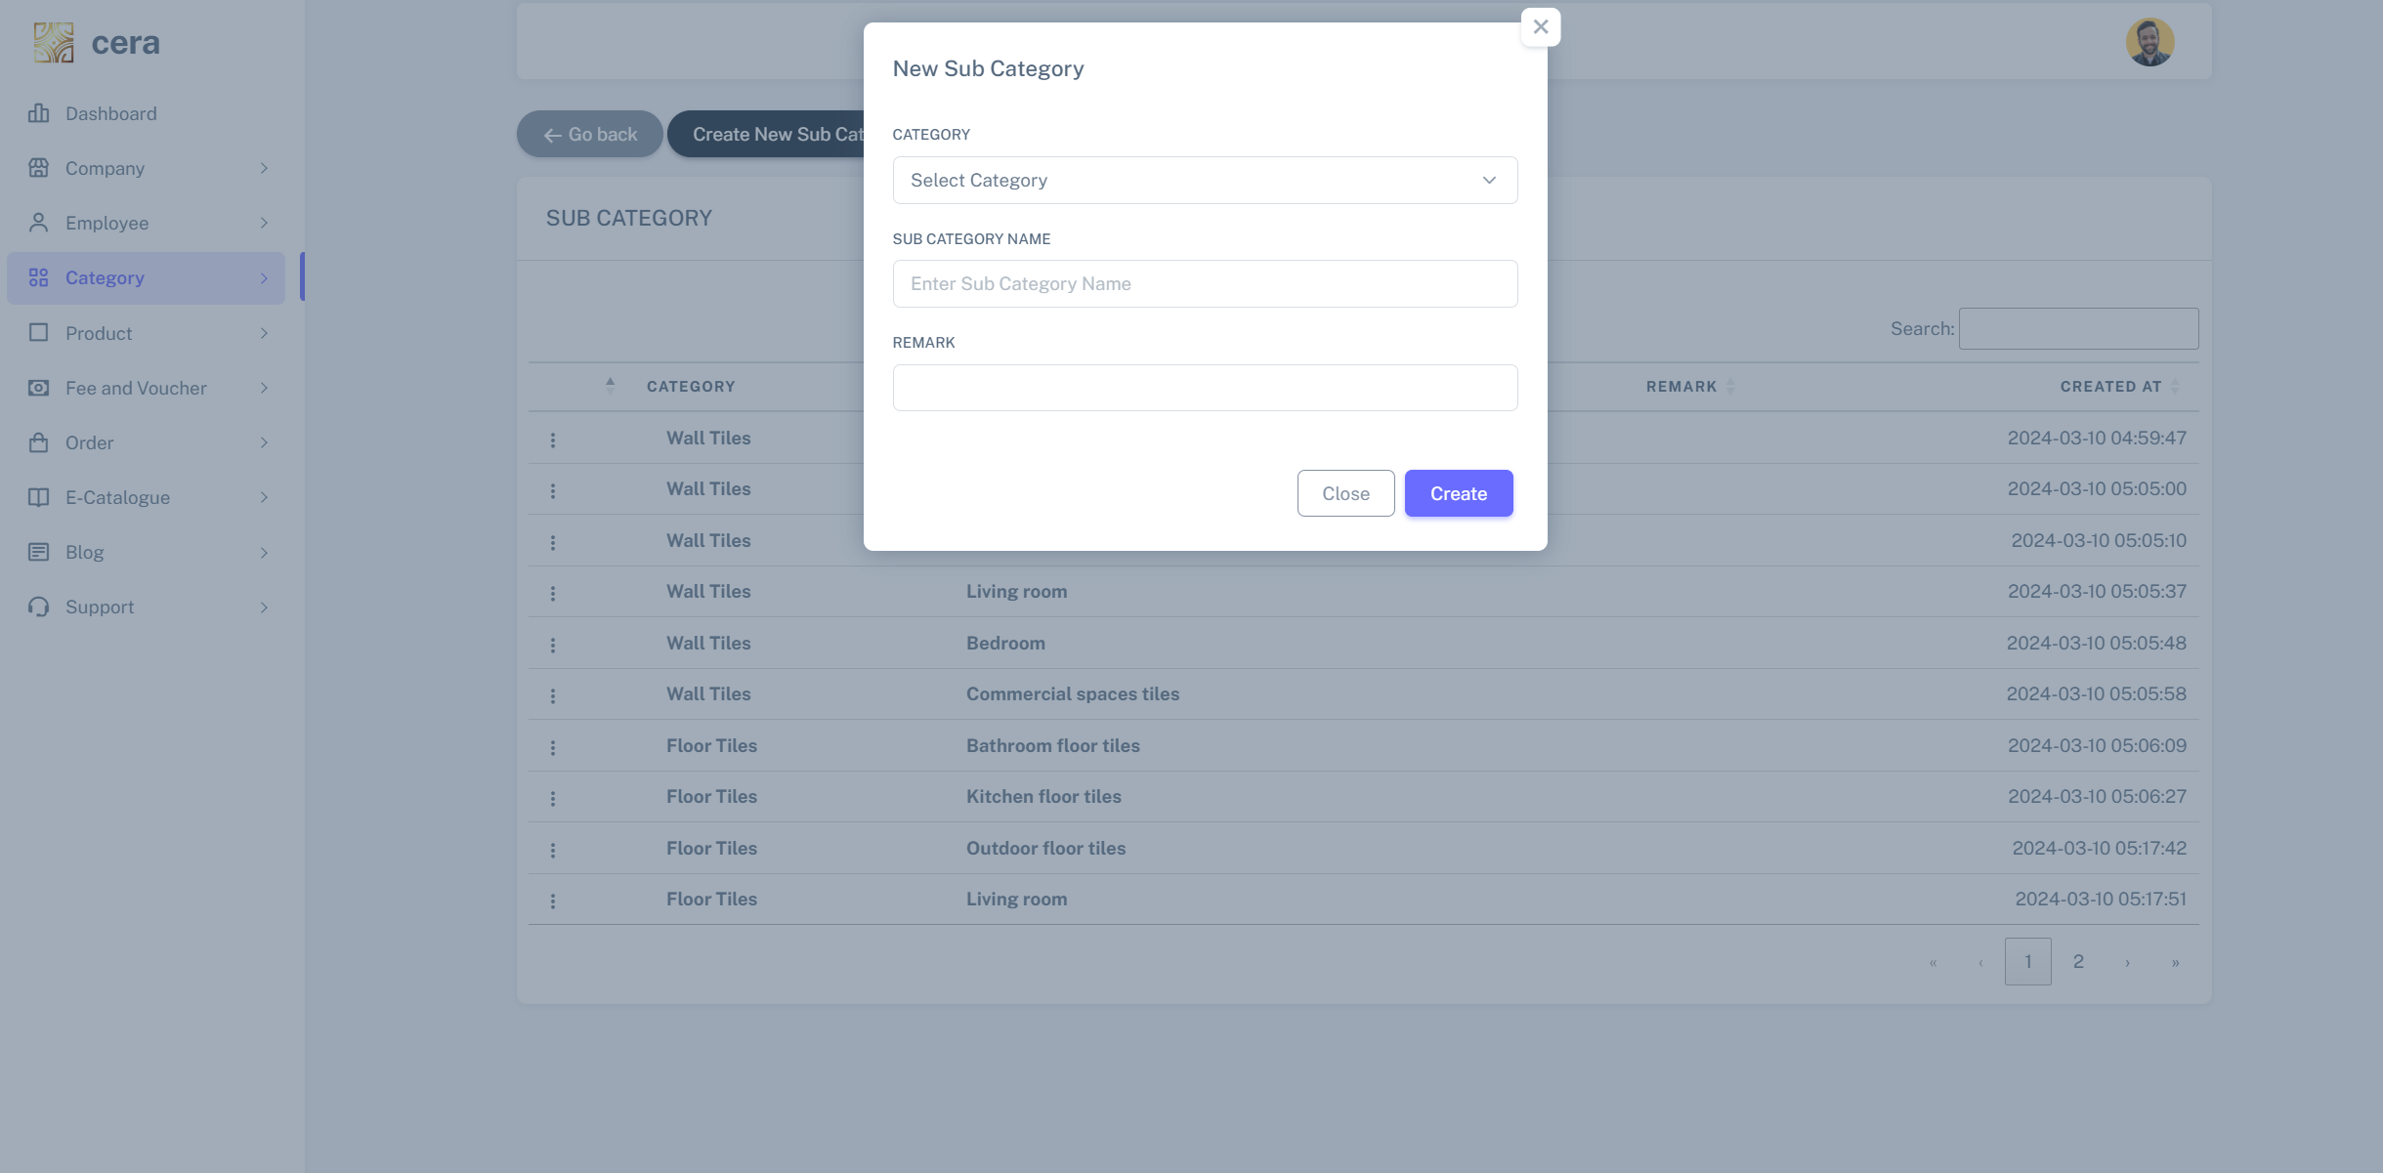

**NOTE: Please kindly note that main category and sub category will appear on navigation section**

1. Manage product

Create on **Create New Product** to create new category or click on three dots icon to edit or delete

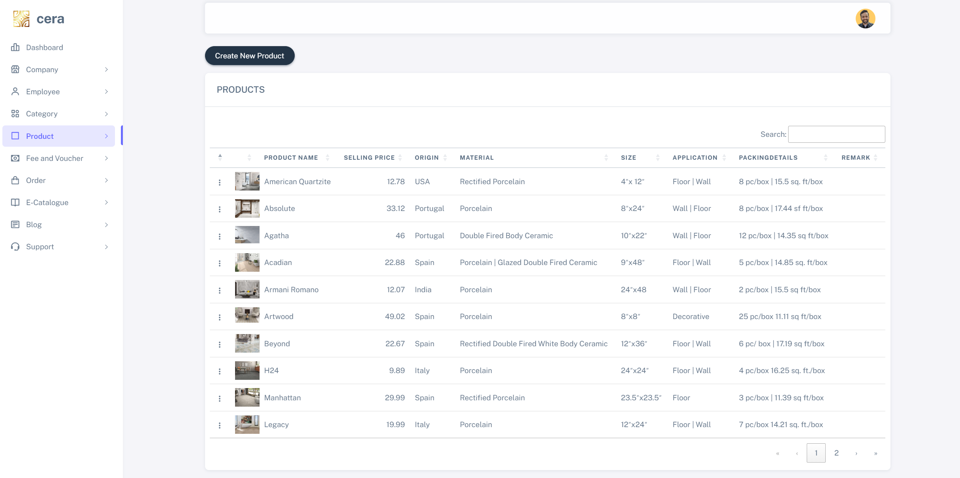

Enter required information and click **Create**

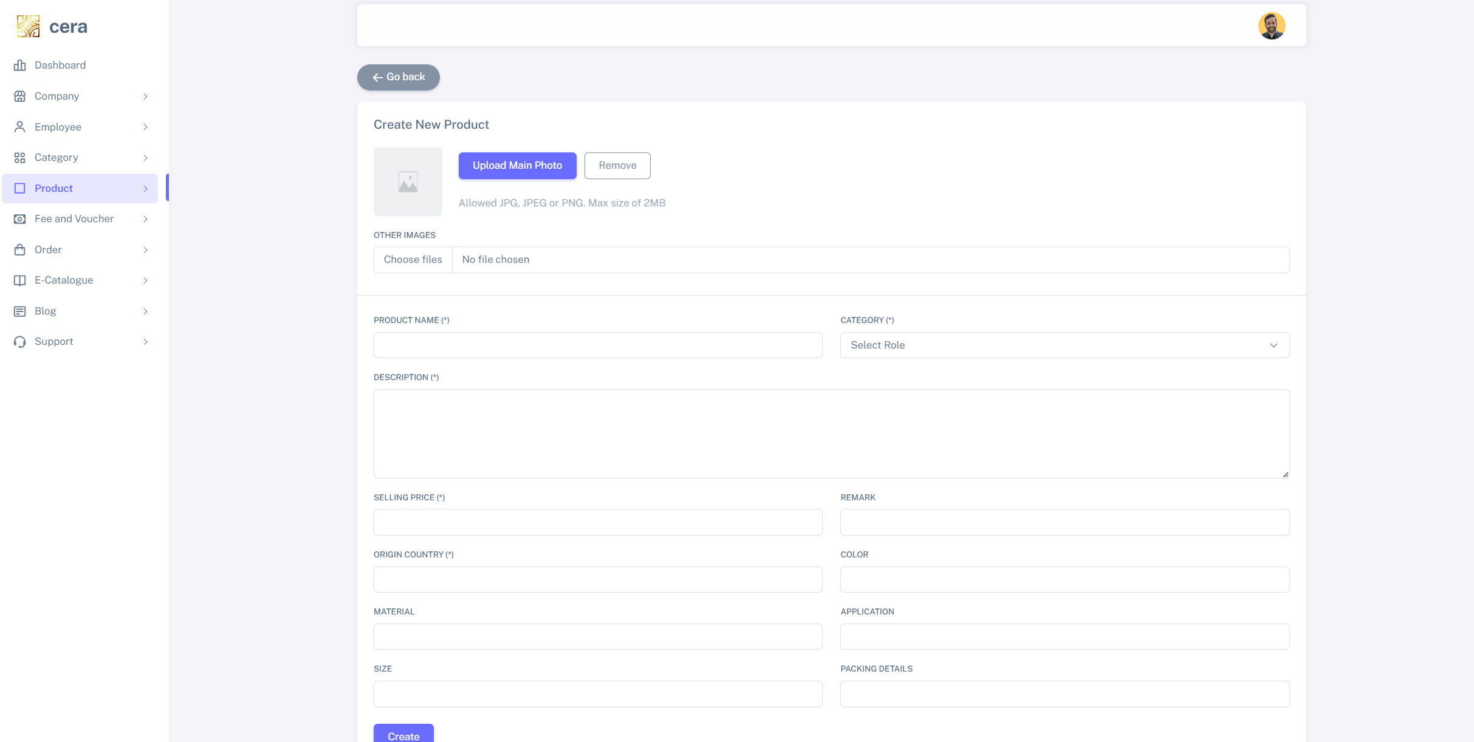

1. Manage delivery fee

Create on **Create New Delivery Fee** to create new category or click on three dots icon to edit or delete.

**Note: These fees will appear as selection in checkout page**

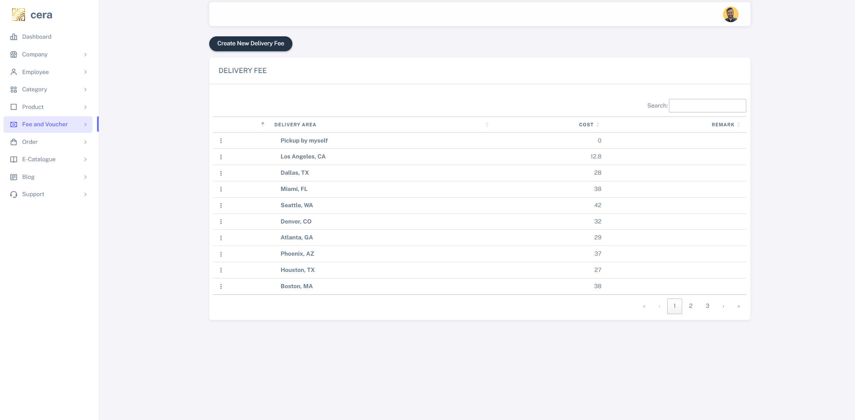

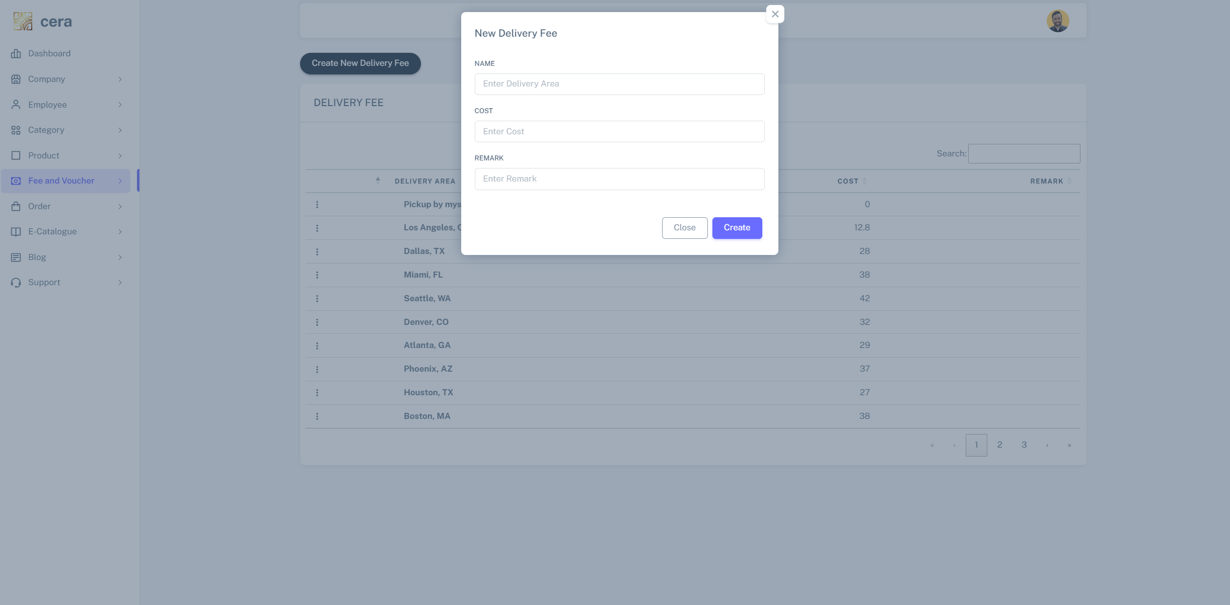

1. Manage voucher

Create on **Create New Voucher** to create new category or click on three dots icon to edit or delete.

Voucher code is unique and is in uppercase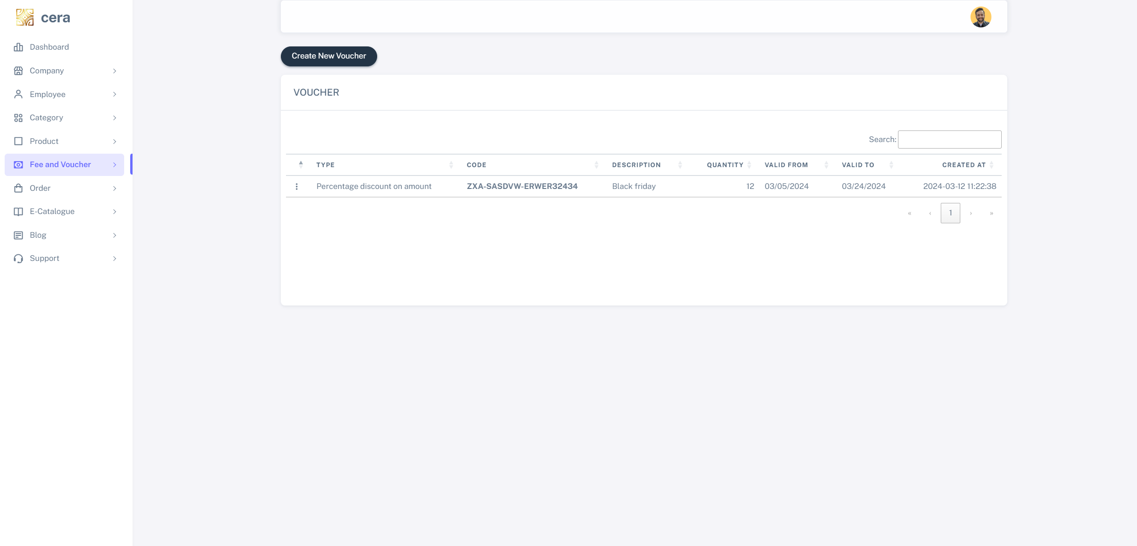

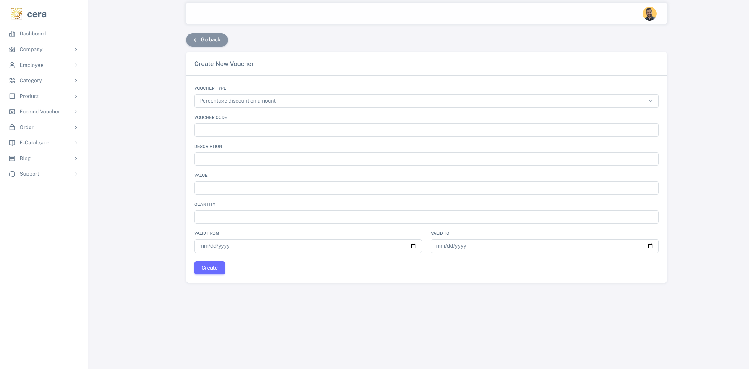

1. See transaction

Order that customer purchase will appear in this section

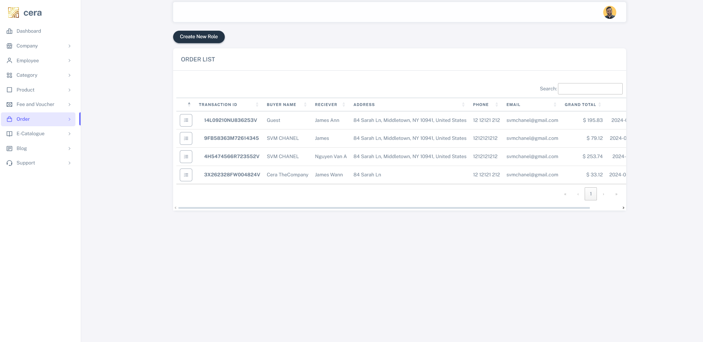

Click on three dots icon to see order details

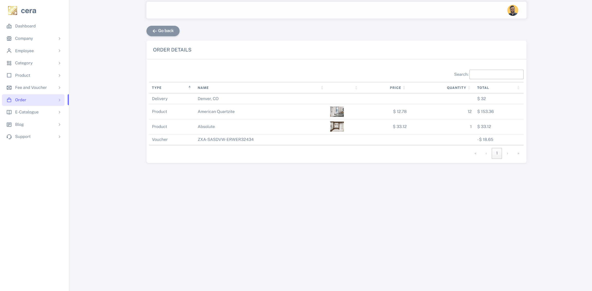

1. Manage E-catalogue type

Create on **Create New Category** to create e-catalogue category

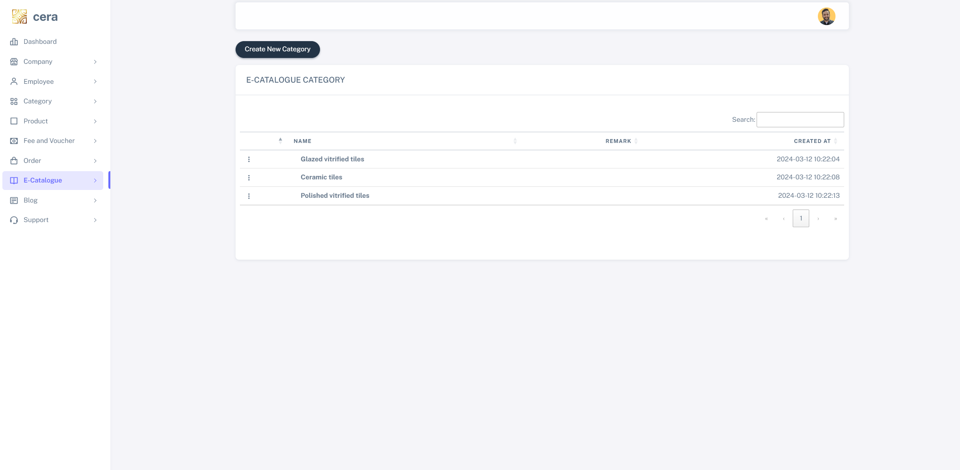

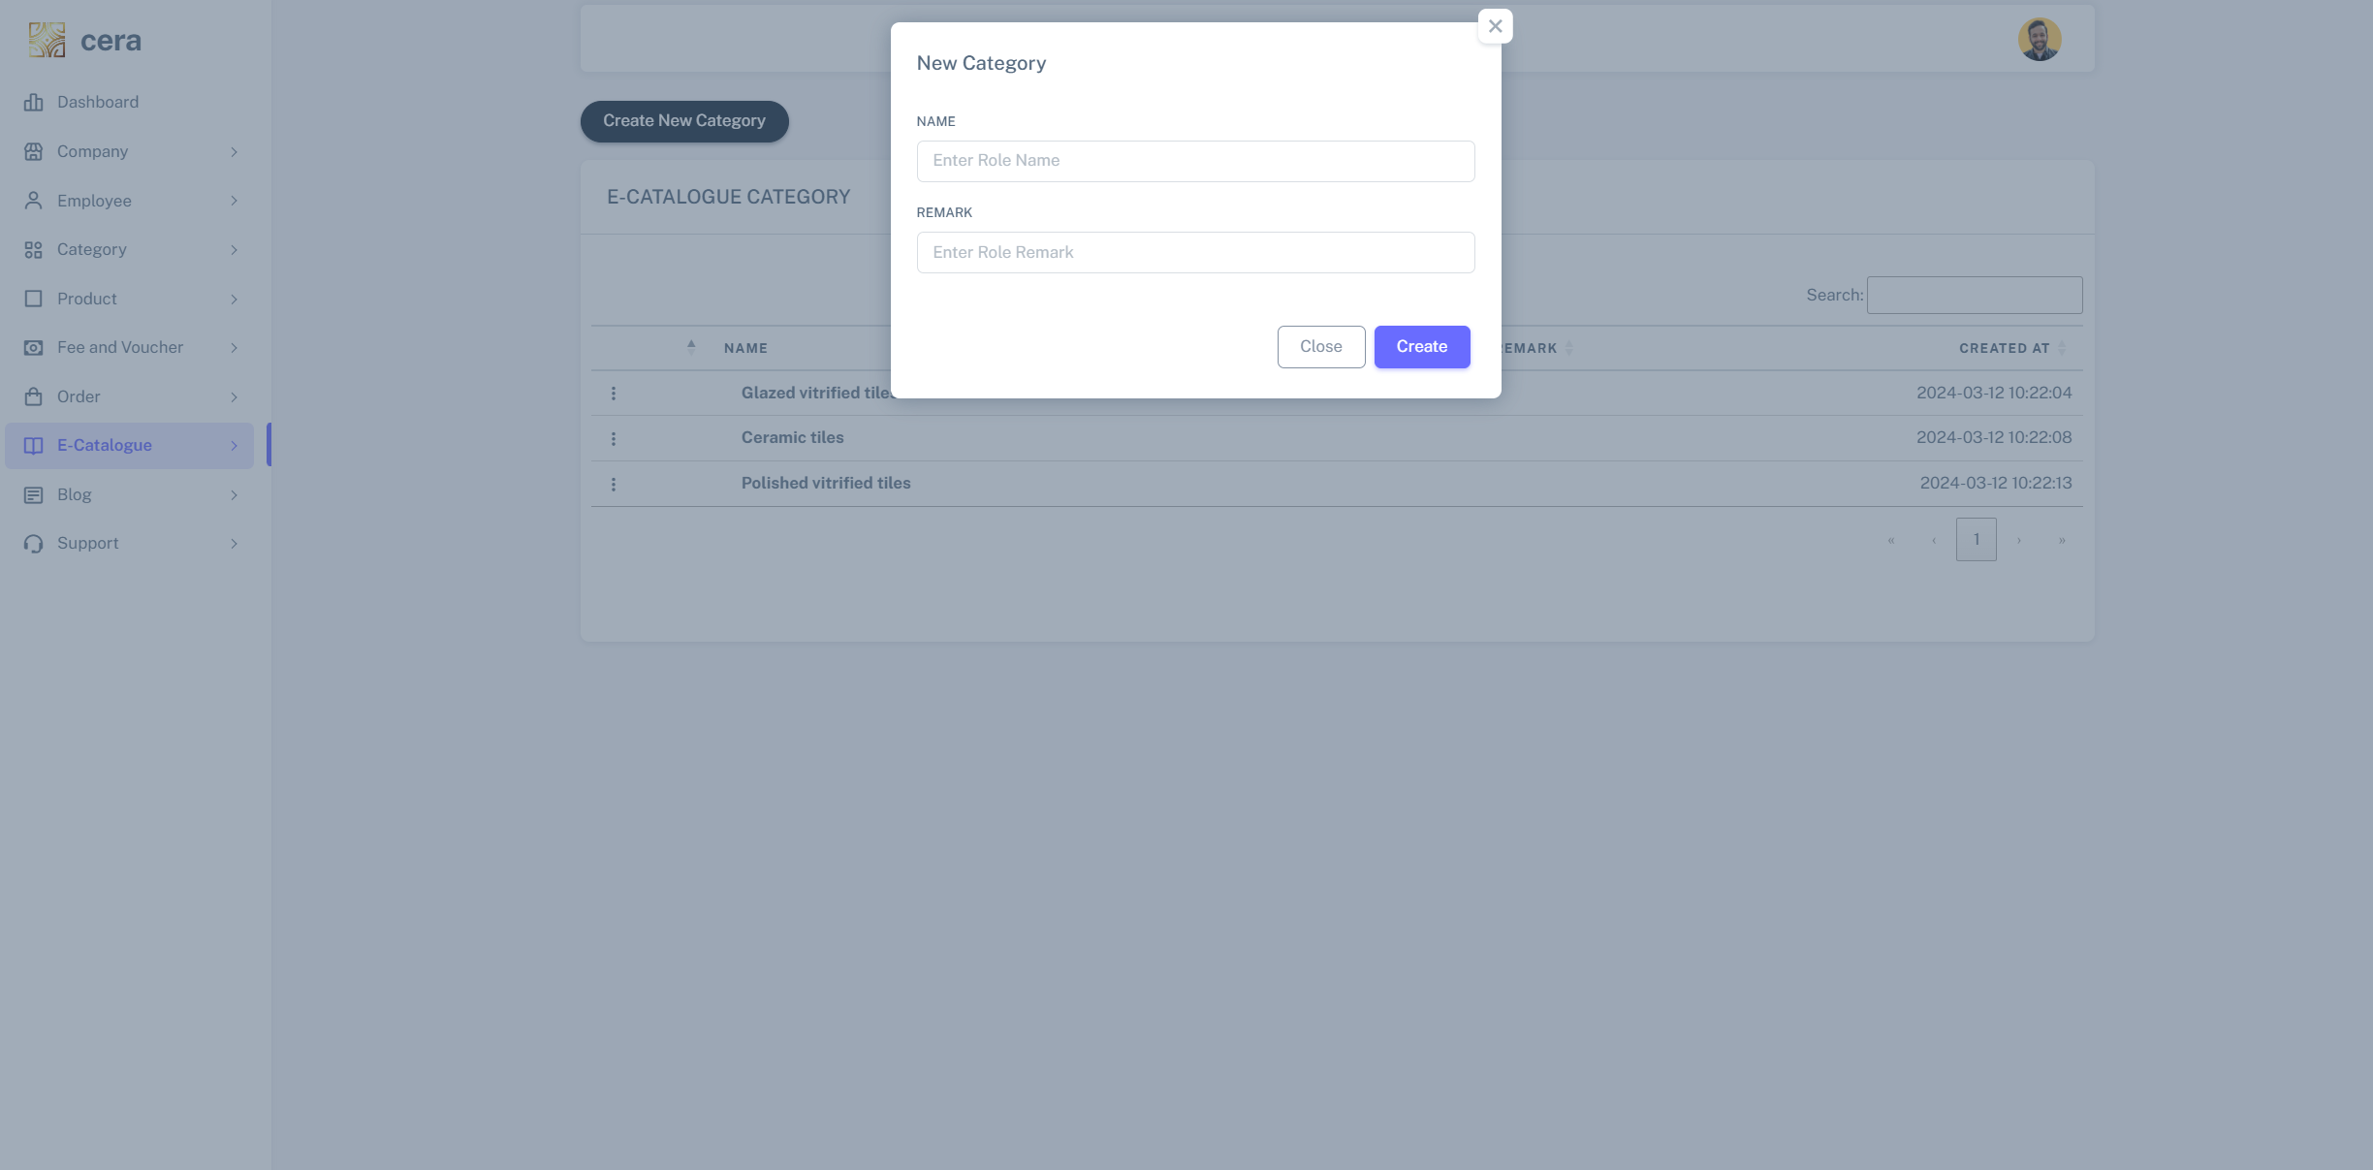

1. Manage E-catalogue Files

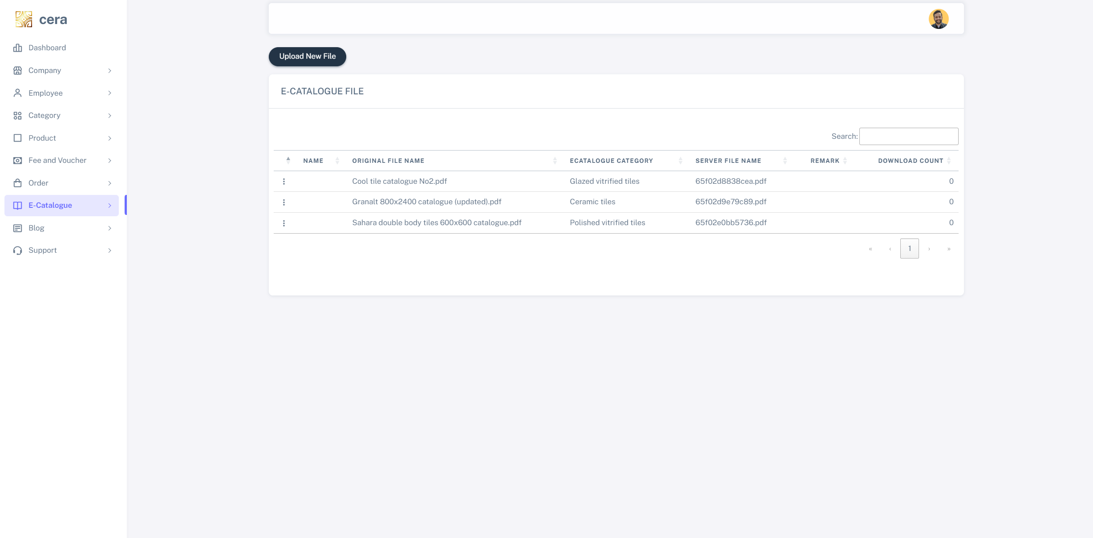

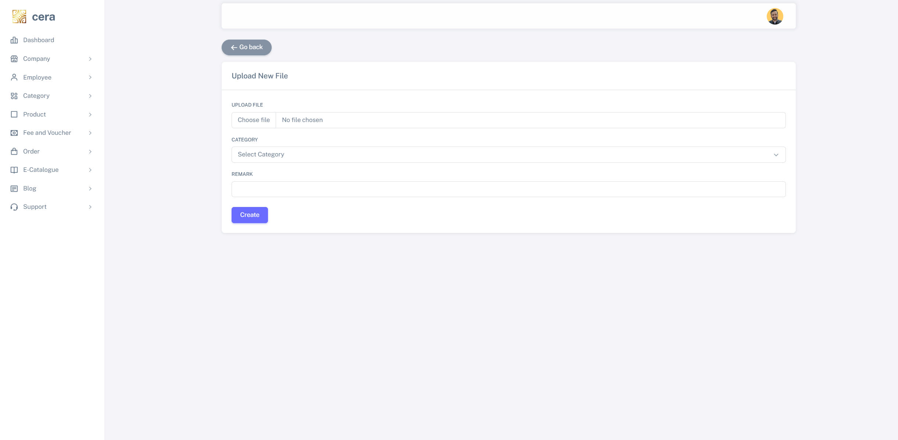

1. Manage Blog category

Click on Create New Category to create new category or click on three dots to edit

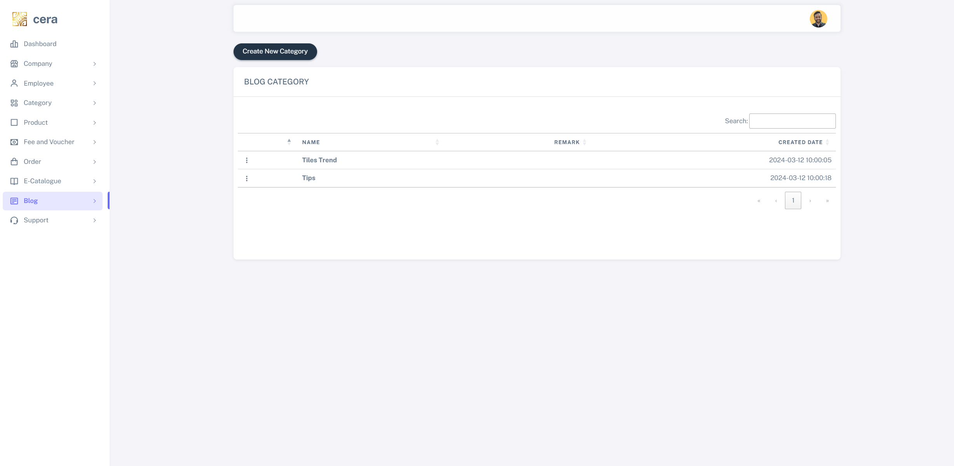

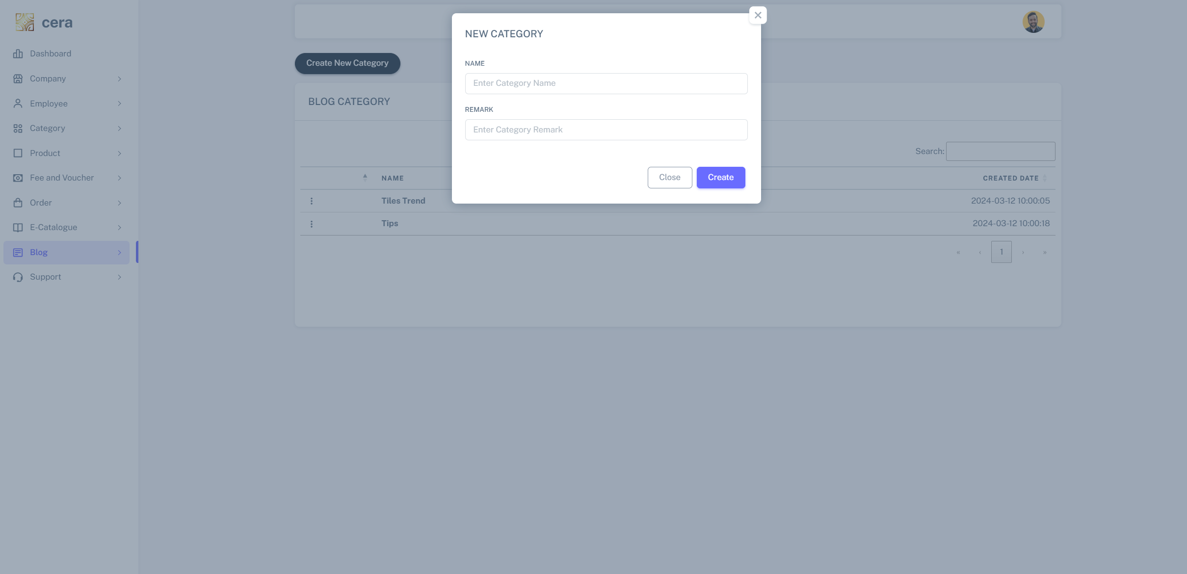

1. Manage blog article

Click on Create New Article to create new blog article or click on three dots to edit

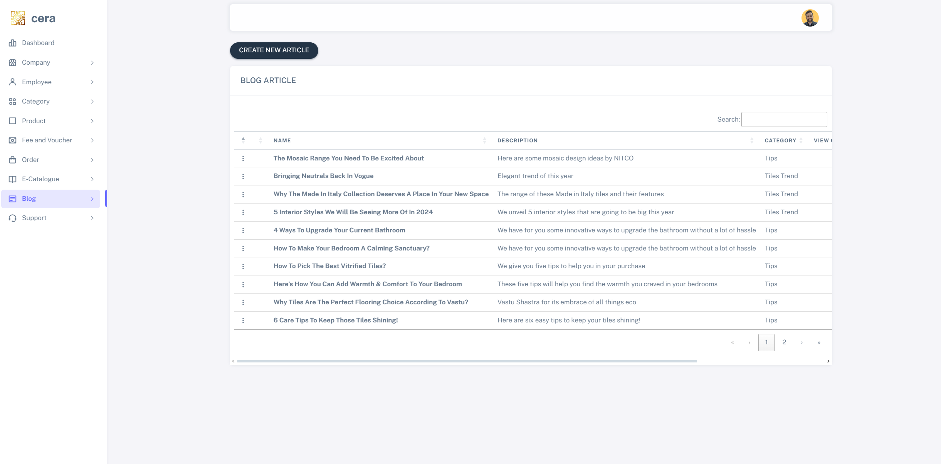

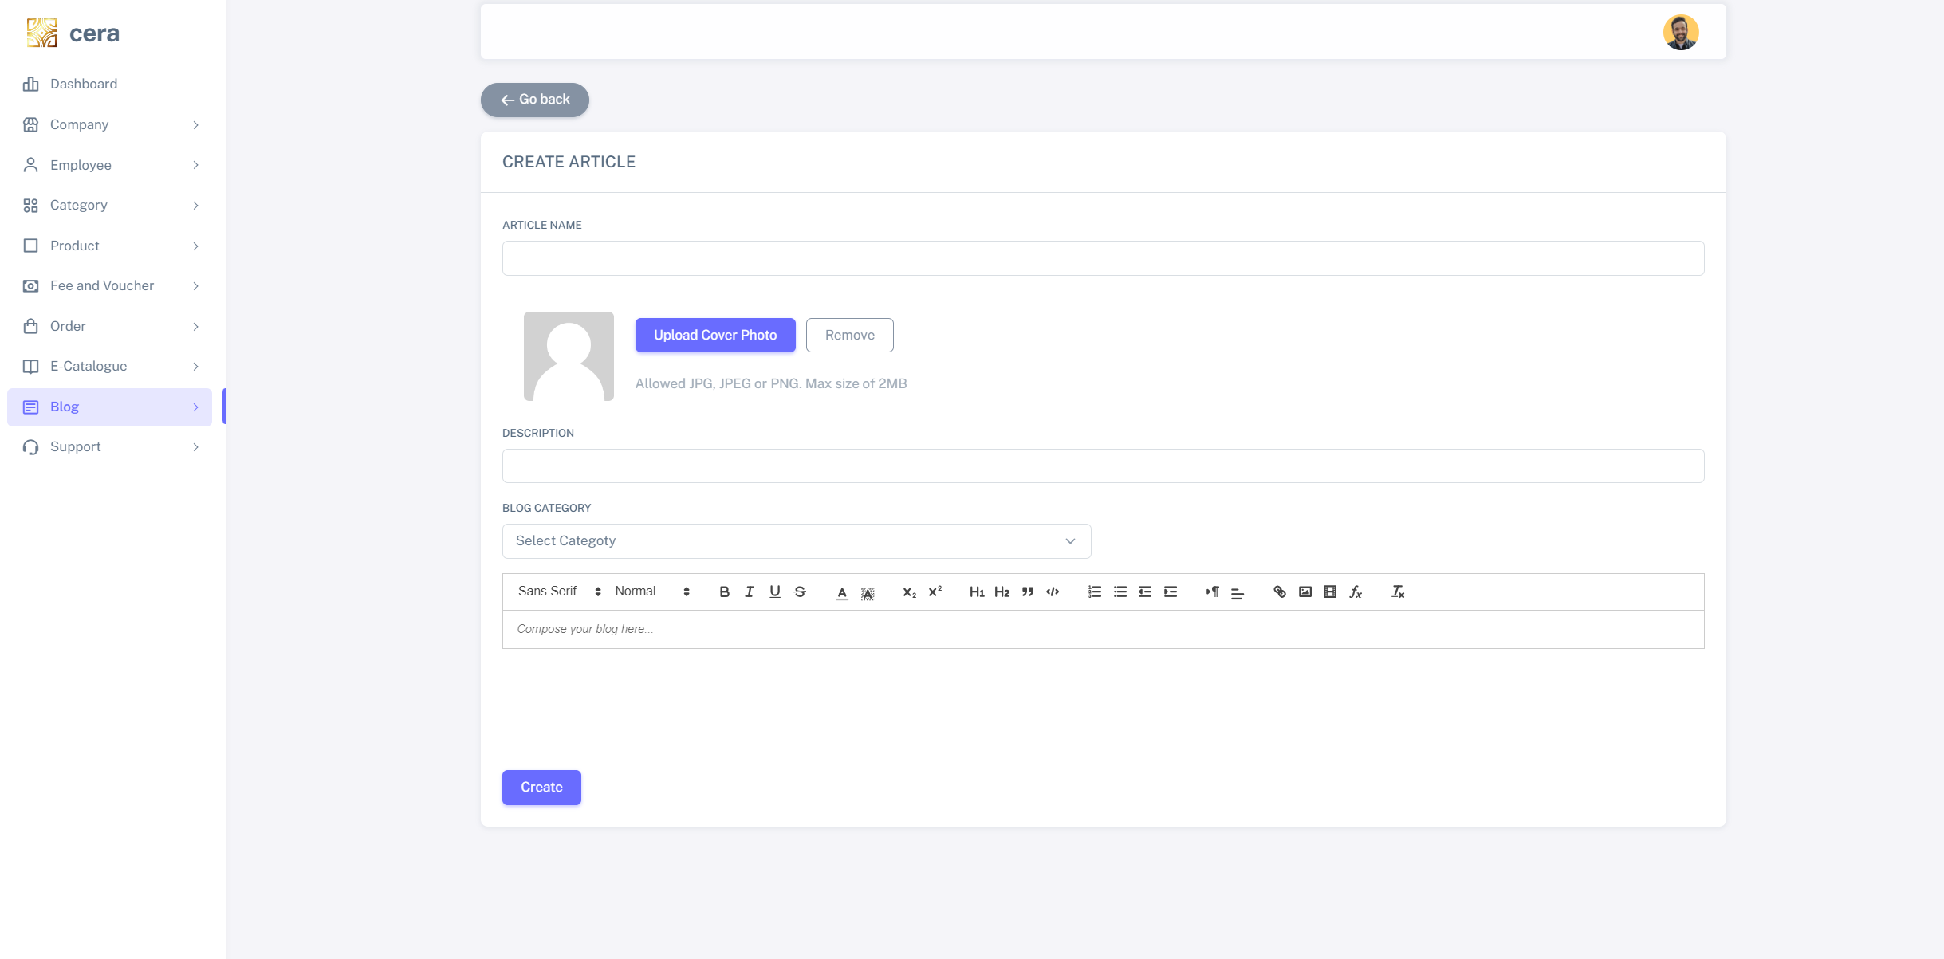

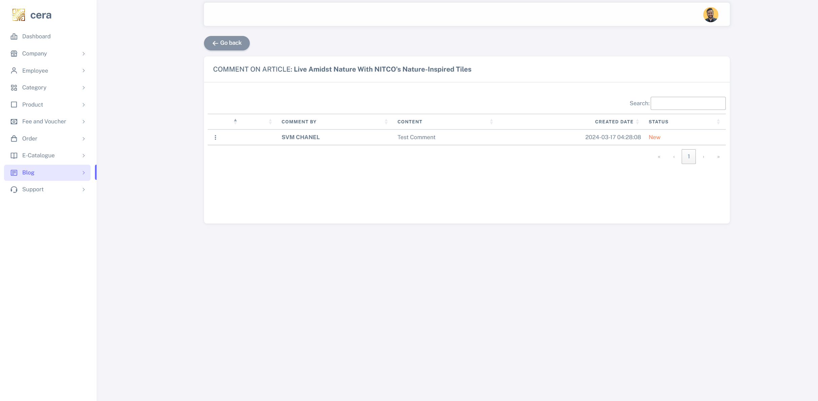

1. Manage contact me request

When user send Contact me request in contact page, those requests will appear here, employee can click on three dots to remake that they have contact user already

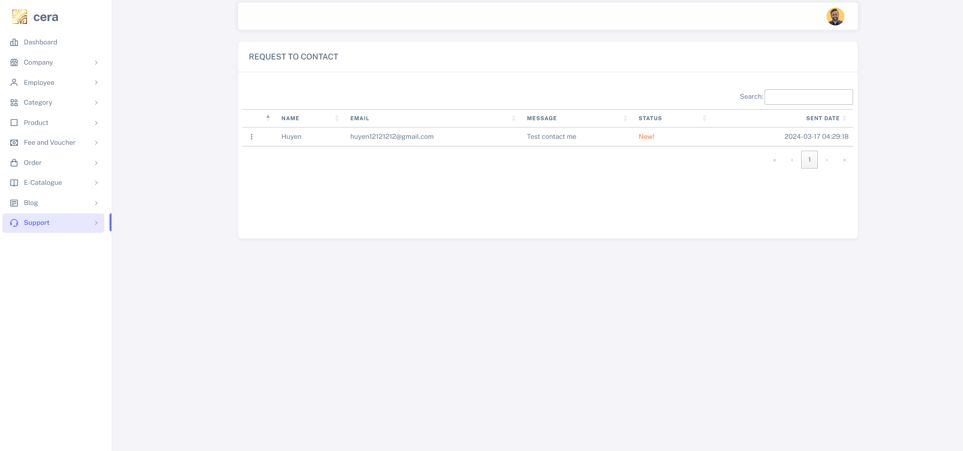

1. Dashboard

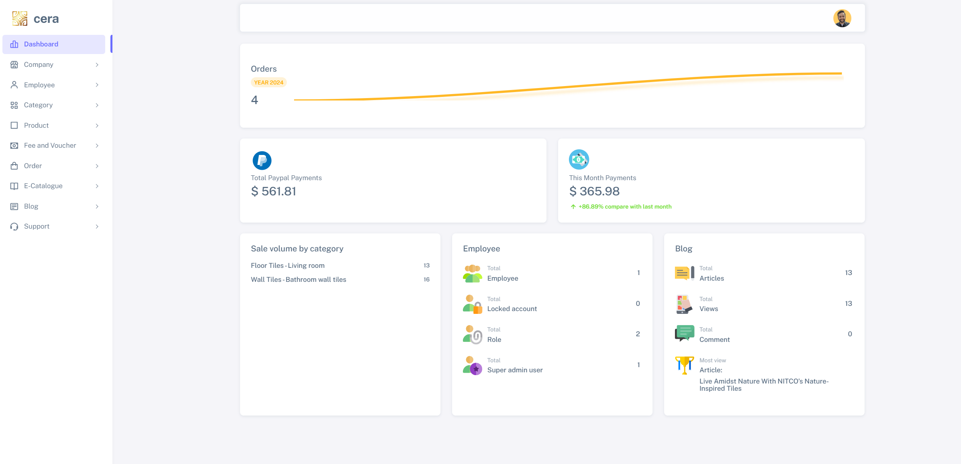

1. **Run Web Application (Web User):**
2. Home Page:

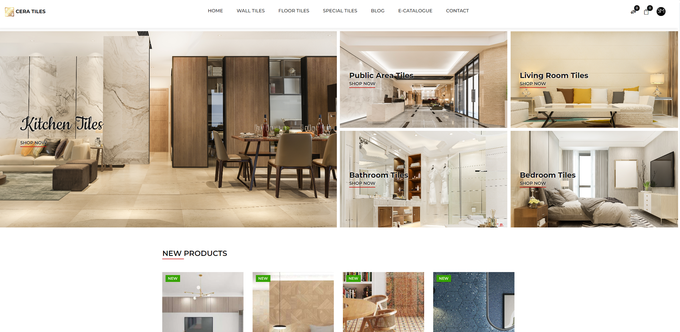

1. Login

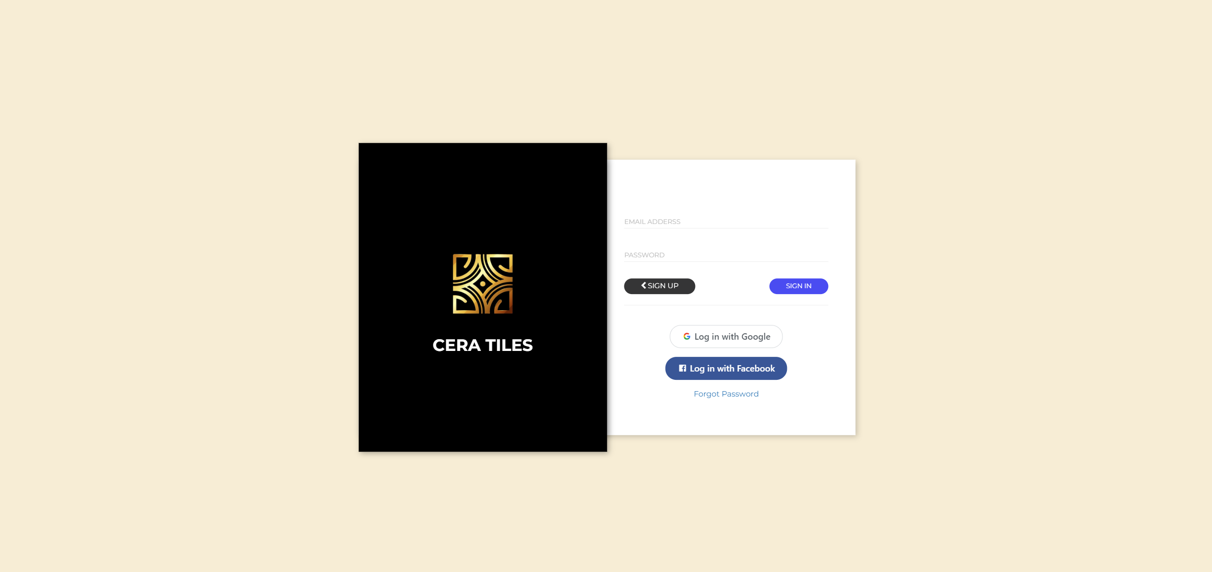

You can create an account or use Facebook or Google account to login

1. Product list

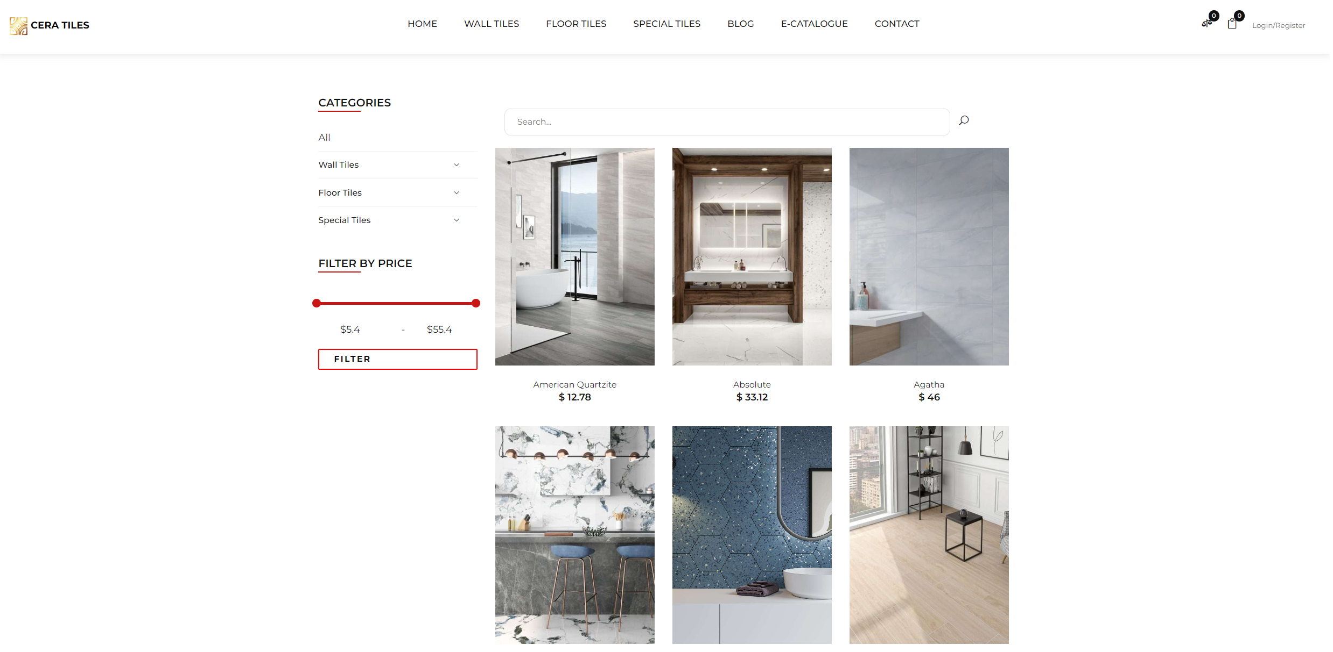

1. Product Details

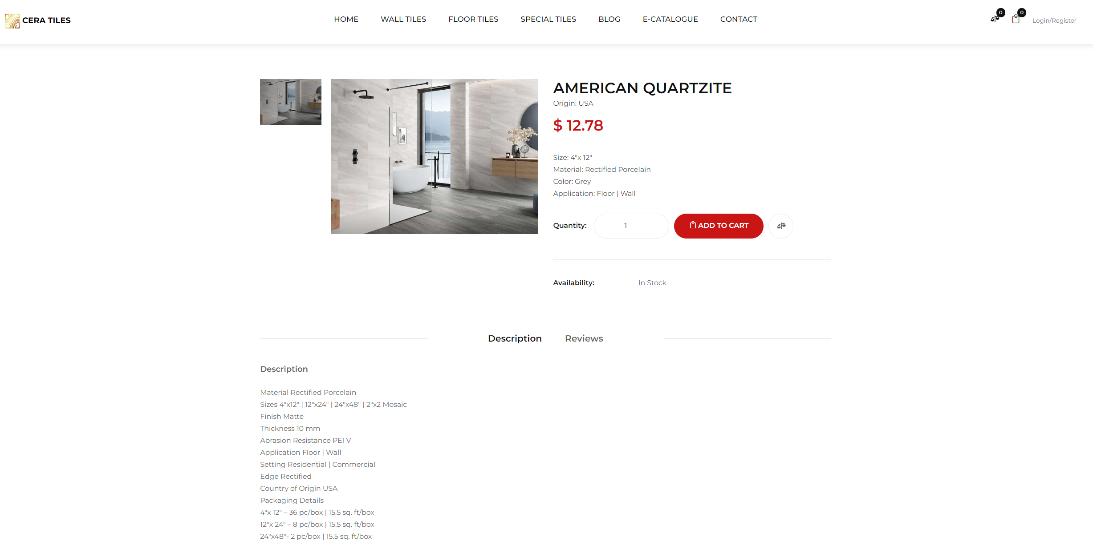

1. Product comparison

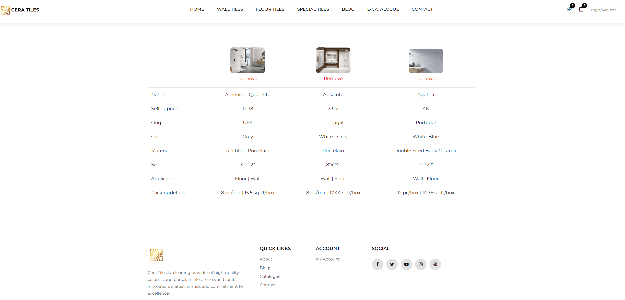

1. Shopping cart

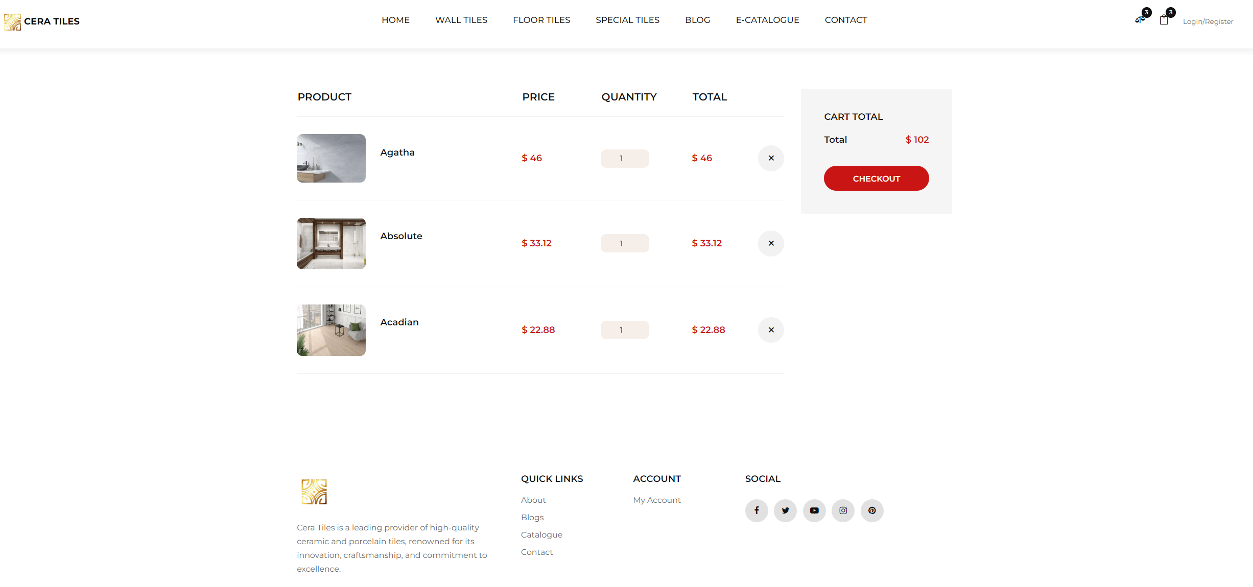

1. Check out

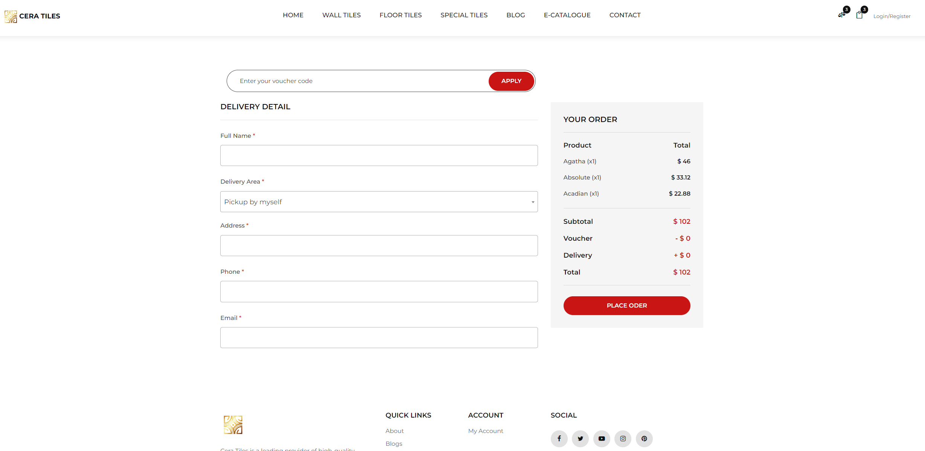

Enter the delivery information and click on **'Check Out'**. You will be redirected to PayPal

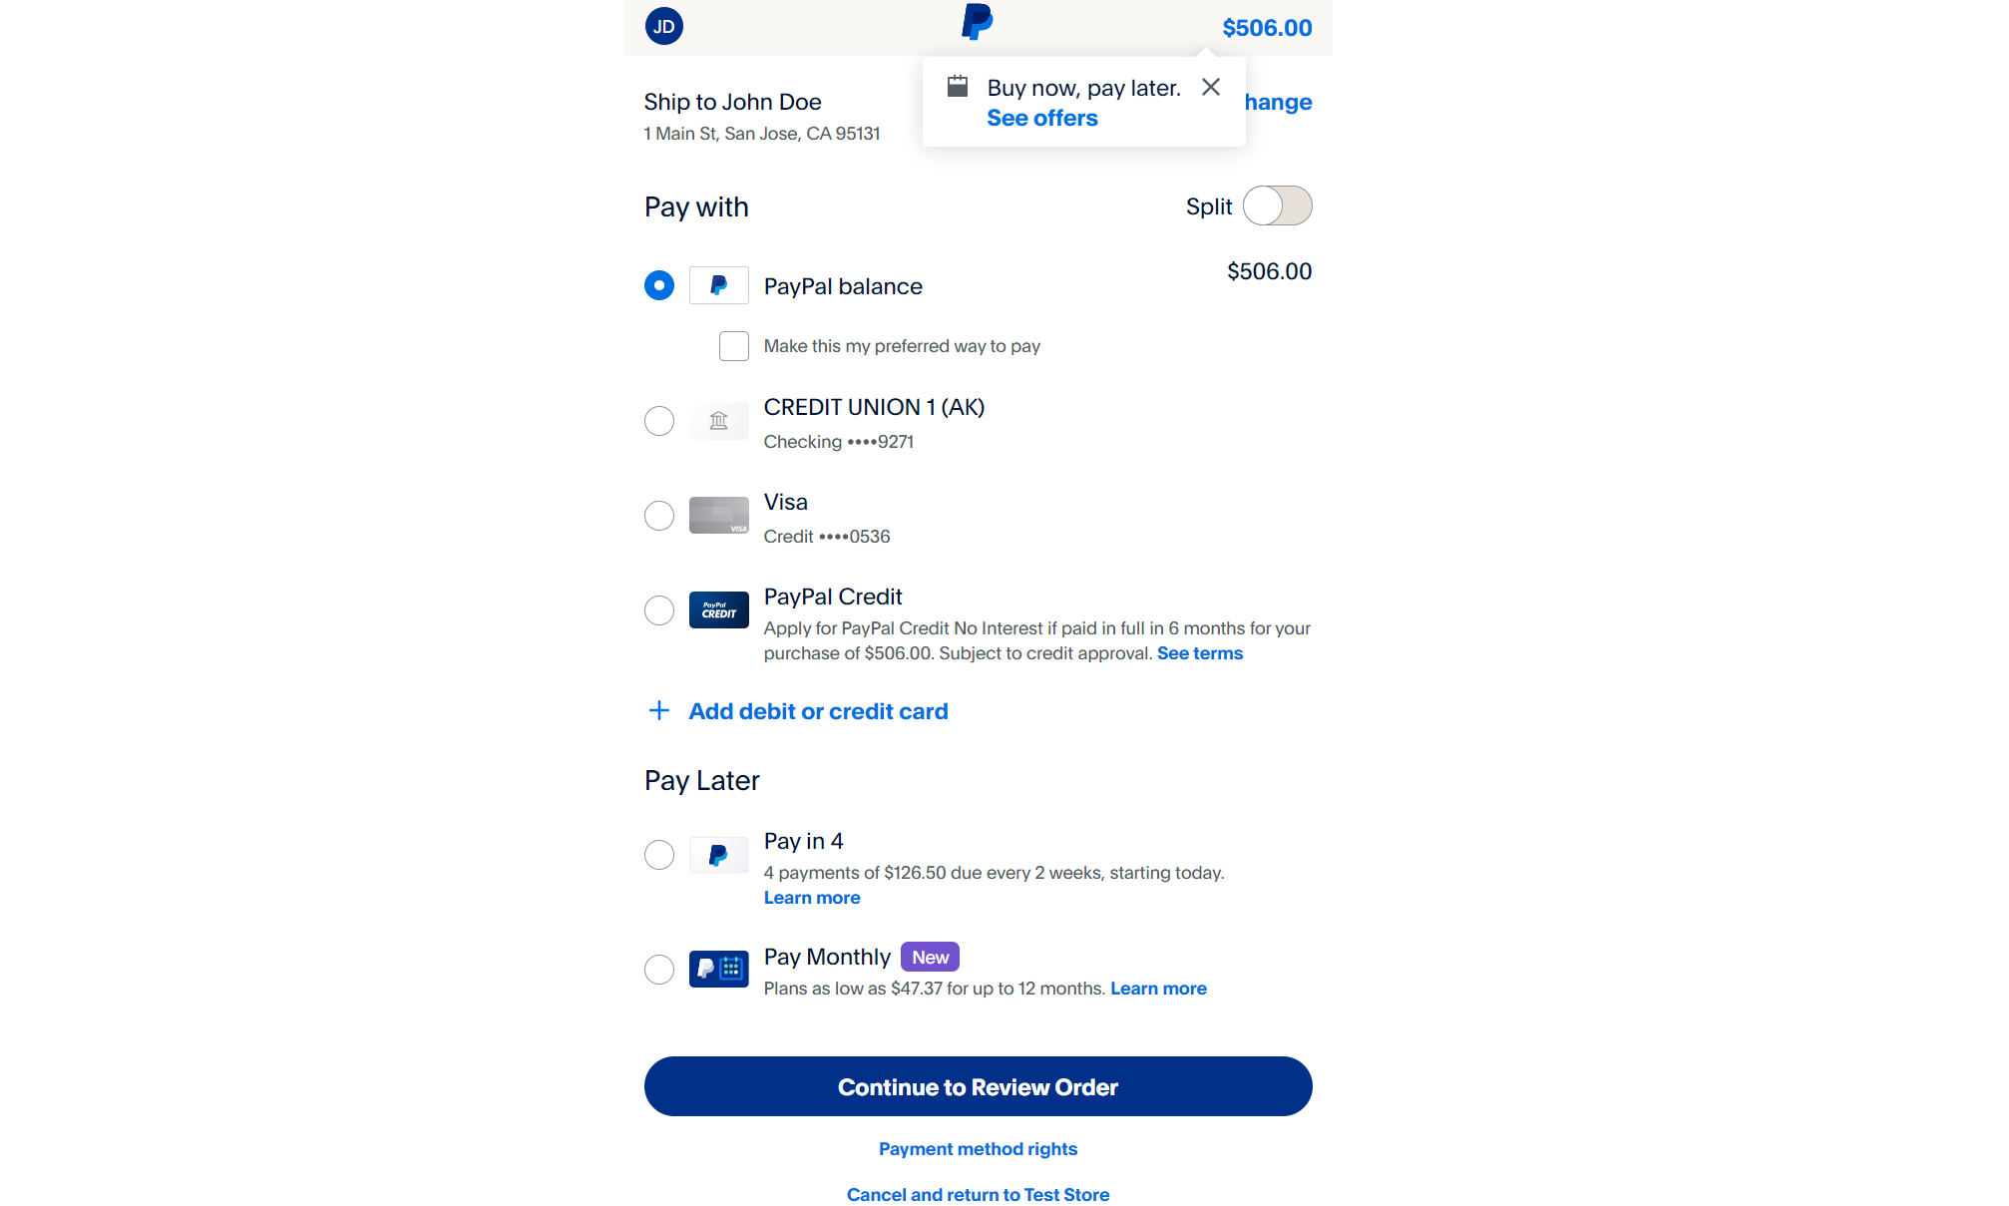

You can check your transaction history in my account section

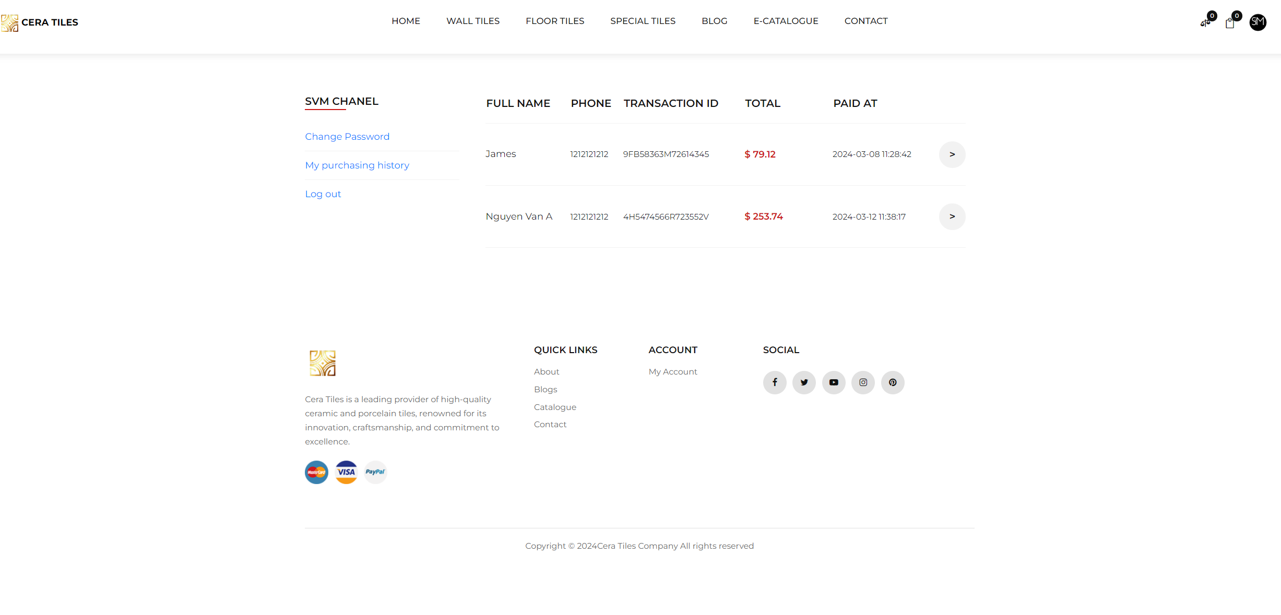

1. Blog

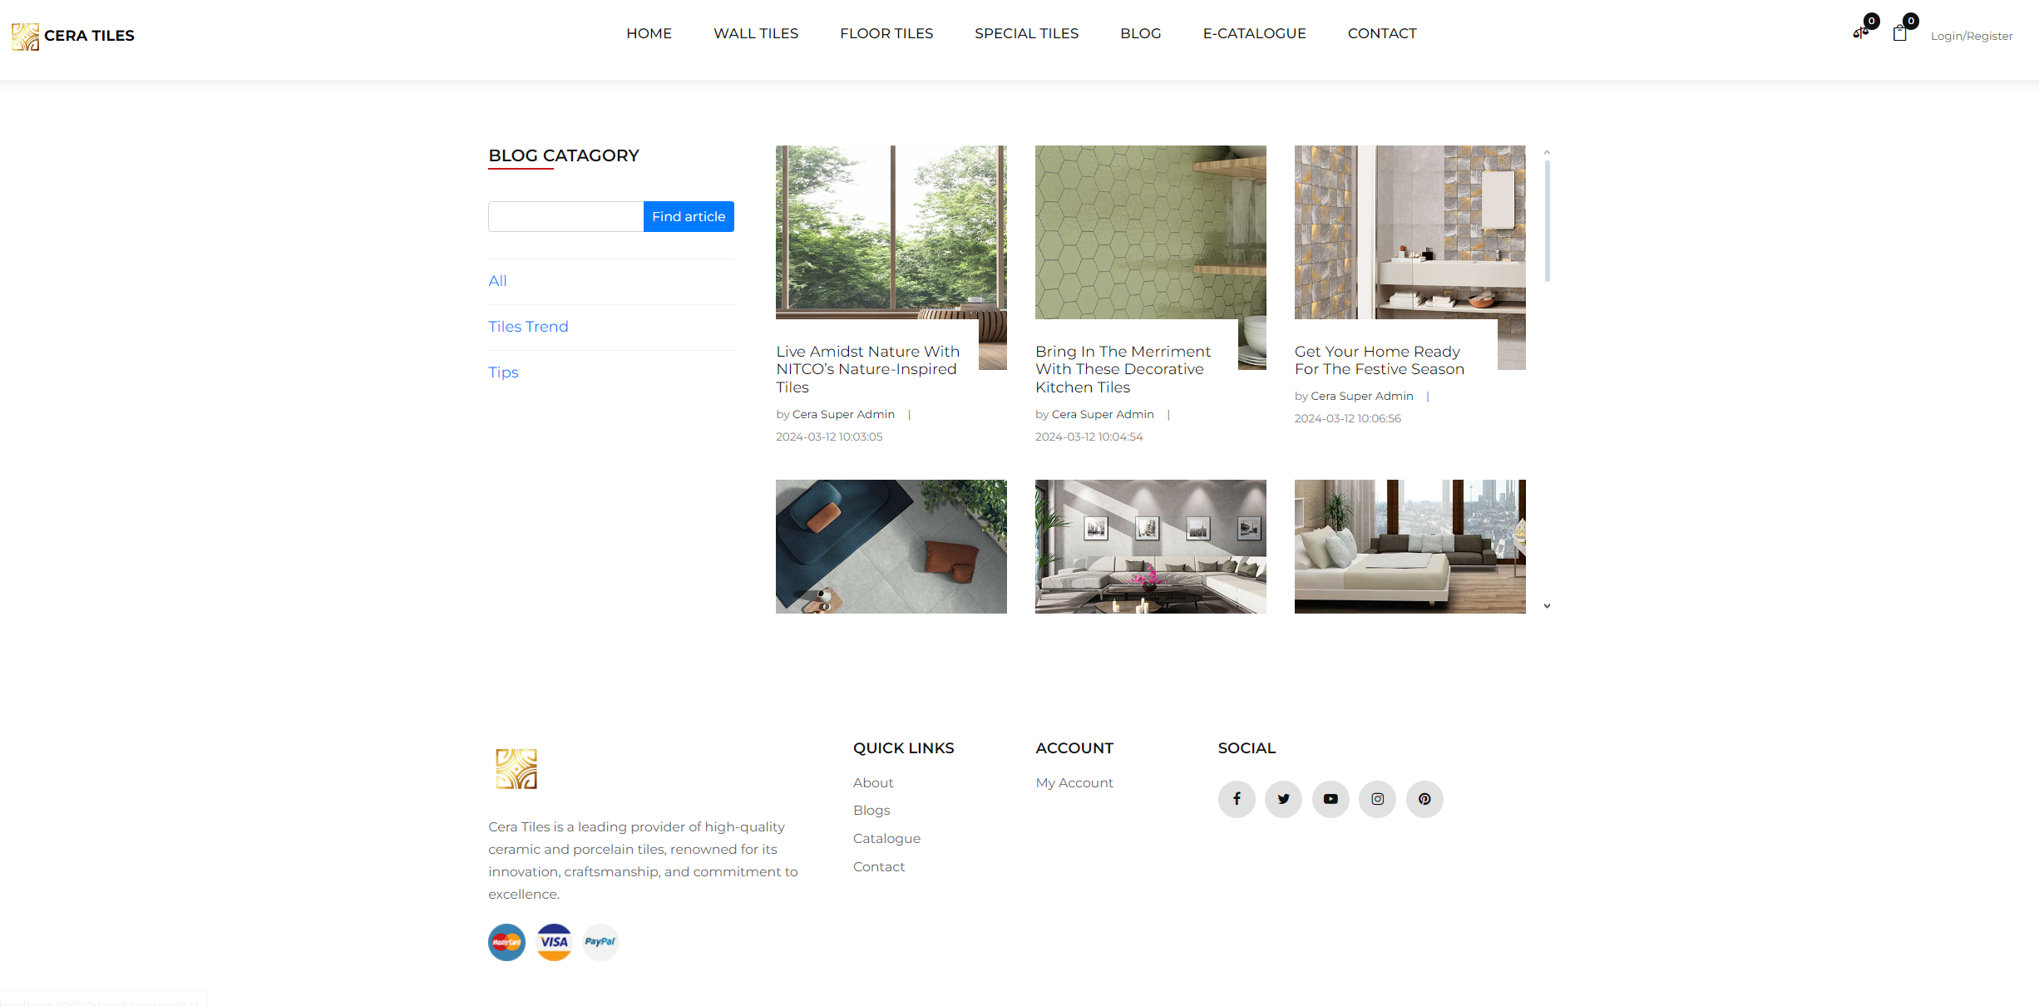

Blog details

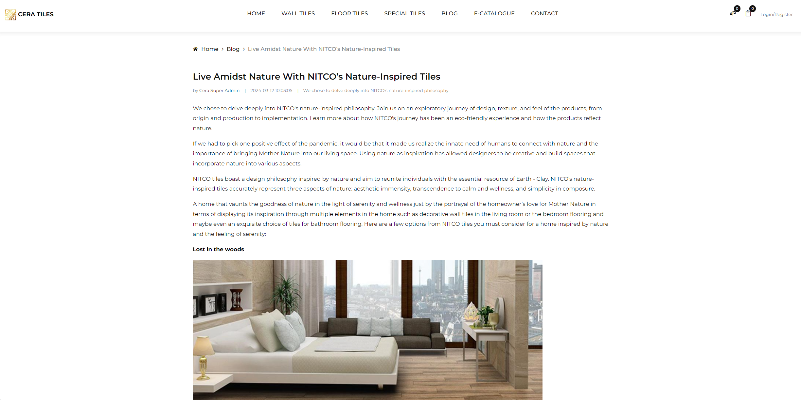

1. E-catalogue: You can download e-catalogue from this page

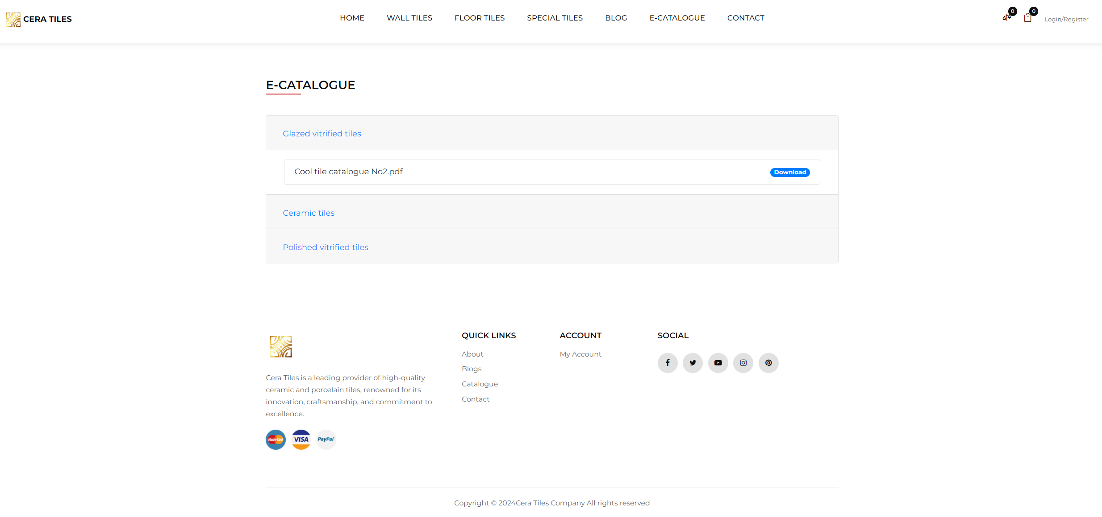

1. On the 'About Us' and 'Contact Me' pages, clicking on the email address should open Outlook or Gmail to send an email from your own email account. Alternatively, you can input your email address in the form provided below, and a Cera employee will contact you later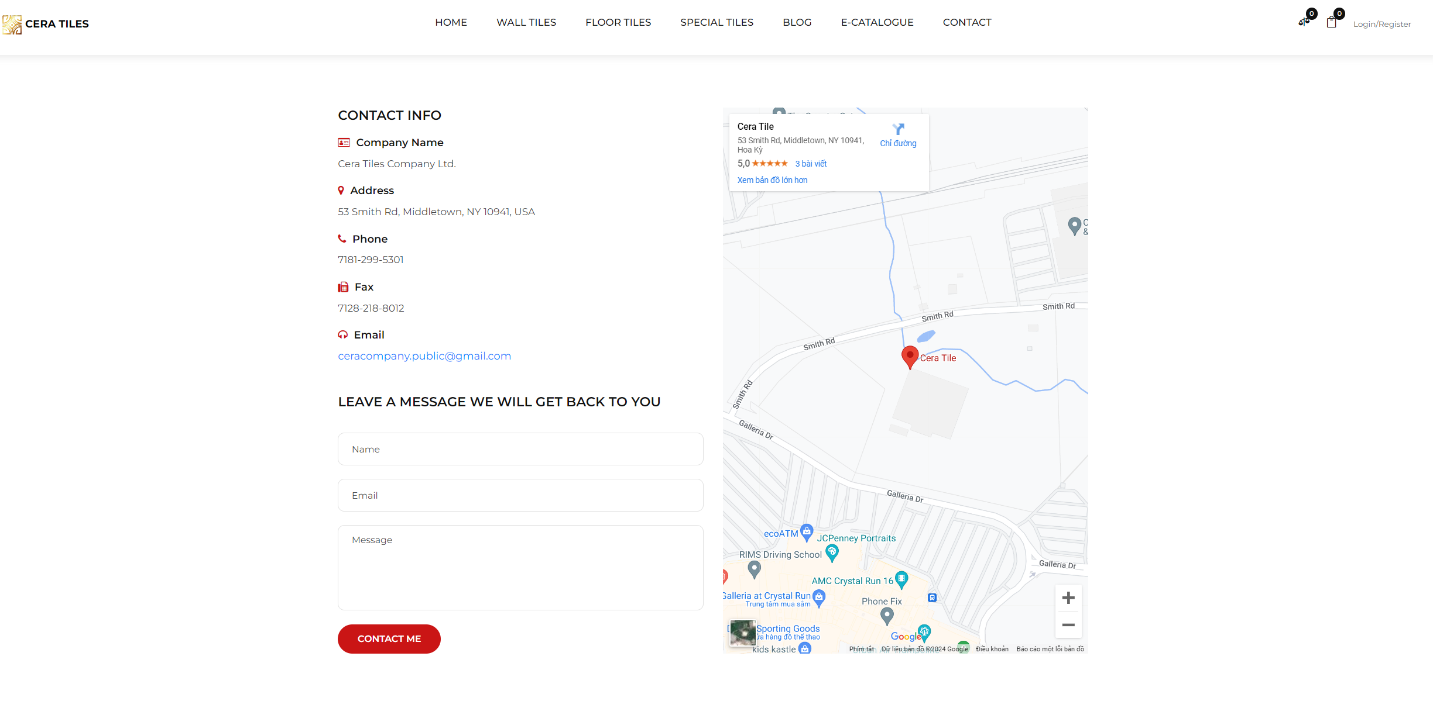
2. **Database**
3. ER Diagram

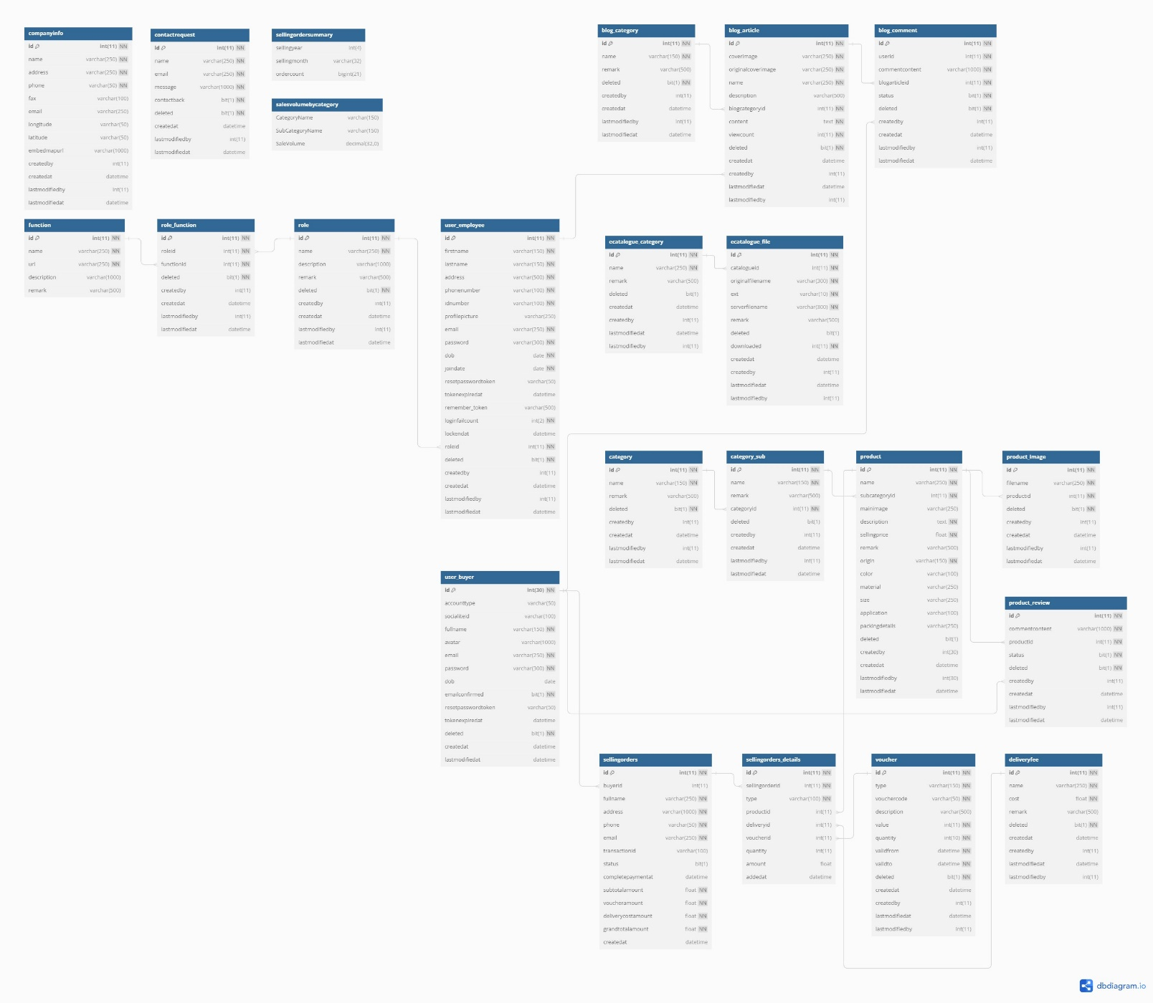

1. Detail of Tables

|  |  |  |  |  |  |  |
| --- | --- | --- | --- | --- | --- | --- |
| Table Name | Column Name | Data Type | Primary Key | Constraint Check Column | Foreign Key Table | Description |
| function | id | int(11) | Yes | Not Null, AUTO_INCREMENT |  | Table has data when deploy, cannot delete or modify |
|  | name | varchar(250) |  | Not Null |  |  |
|  | url | varchar(250) |  | Not Null |  |  |
|  | description | varchar(1000) |  | Null |  |  |
|  | remark | varchar(500) |  | Null |  |  |
| role | id | int(11) | Yes | Not Null, AUTO_INCREMENT |  |  |
|  | name | varchar(250) |  | Not Null |  |  |
|  | description | varchar(1000) |  | Null |  |  |
|  | remark | varchar(500) |  | Null |  |  |
|  | deleted | bit(1) |  | Not Null |  |  |
|  | createdby | int(11) |  | Null |  |  |
|  | createdat | datetime |  | Null |  |  |
|  | lastmodifiedby | int(11) |  | Null |  |  |
|  | lastmodifiedat | datetime |  | Null |  |  |
| role_function | id | int(11) | Yes | Not Null, AUTO_INCREMENT |  |  |
|  | roleid | int(11) |  | Not Null |  | role |
|  | functionid | int(11) |  | Not Null |  | function |
|  | deleted | bit(1) |  | Not Null |  |  |
|  | createdby | int(11) |  | Null |  |  |
|  | createdat | datetime |  | Null |  |  |
|  | lastmodifiedby | int(11) |  | Null |  |  |
|  | lastmodifiedat | datetime |  | Null |  |  |
| blog_category | id | int(11) | Yes | Not Null, AUTO_INCREMENT |  |  |
|  | name | varchar(150) |  | Not Null |  |  |
|  | remark | varchar(500) |  | Null |  |  |
|  | deleted | bit(1) |  | Not Null |  |  |
|  | createdby | int(11) |  | Null |  |  |
|  | createdat | datetime |  | Null |  |  |
|  | lastmodifiedby | int(11) |  | Null |  |  |
|  | lastmodifiedat | datetime |  | Null |  |  |
| blog_article | id | int(11) | Yes | Not Null, AUTO_INCREMENT |  |  |
|  | coverimage | varchar(250) |  | Not Null |  |  |
|  | originalcoverimage | varchar(250) |  | Not Null |  |  |
|  | name | varchar(250) |  | Not Null |  |  |
|  | description | varchar(500) |  | Null |  |  |
|  | blogcategoryid | int(11) |  | Not Null |  | blog_category |
|  | content | text |  | Not Null |  |  |
|  | viewcount | int(11) |  | Not Null |  |  |
|  | deleted | bit(1) |  | Not Null |  |  |
|  | createdby | int(11) |  | Null |  | user_employee |
|  | createdat | datetime |  | Null |  |  |
|  | lastmodifiedby | int(11) |  | Null |  |  |
|  | lastmodifiedat | datetime |  | Null |  |  |
| blog_category | id | int(11) | Yes | Not Null  AUTO_INCREMENT |  |  |
|  | name | varchar(150) |  | Not Null |  |  |
|  | remark | varchar(500) |  | Null |  |  |
|  | deleted | bit(1) |  | Not Null |  |  |
|  | createdby | int(11) |  | Null |  |  |
|  | createdat | datetime |  | Null |  |  |
|  | lastmodifiedby | int(11) |  | Null |  |  |
|  | lastmodifiedat | datetime |  | Null |  |  |
| blog_comment | id | int(11) | Yes | Not Null  AUTO_INCREMENT |  |  |
|  | userid | int(11) |  | Null |  |  |
|  | commentcontent | varchar(1000) |  | Null |  |  |
|  | blogarticleid | int(11) |  | Null | blog_article |  |
|  | status | bit(1) |  | Null |  |  |
|  | deleted | bit(1) |  | Null |  |  |
|  | createdby | int(11) |  | Not Null | user_buyer |  |
|  | createdat | datetime |  | Not Null |  |  |
|  | lastmodifiedby | int(11) |  | Not Null |  |  |
|  | lastmodifiedat | datetime |  | Not Null |  |  |
| category | id | int(11) | Yes | Not Null  AUTO_INCREMENT |  |  |
|  | name | varchar(150) |  | Null |  |  |
|  | remark | varchar(500) |  | Not Null |  |  |
|  | deleted | bit(1) |  | Null |  |  |
|  | createdby | int(11) |  | Not Null |  |  |
|  | createdat | datetime |  | Not Null |  |  |
|  | lastmodifiedby | int(11) |  | Not Null |  |  |
|  | lastmodifiedat | datetime |  | Not Null |  |  |
| category_sub | id | int(11) | Yes | Not Null  AUTO_INCREMENT |  |  |
|  | name | varchar(150) |  | Null |  |  |
|  | remark | varchar(500) |  | Not Null |  |  |
|  | categoryid | int(11) |  | Null | category |  |
|  | deleted | bit(1) |  | Not Null |  |  |
|  | createdby | int(11) |  | Not Null |  |  |
|  | createdat | datetime |  | Not Null |  |  |
|  | lastmodifiedby | int(11) |  | Not Null |  |  |
|  | lastmodifiedat | datetime |  | Not Null |  |  |
| product | id | int(11) | Yes | Not Null  AUTO_INCREMENT |  |  |
|  | name | varchar(250) |  | Null |  |  |
|  | subcategoryid | int(11) |  | Not Null | category_sub |  |
|  | mainimage | varchar(250) |  | Not Null |  |  |
|  | description | text |  | Null |  |  |
|  | sellingprice | float unsigned |  | Null |  |  |
|  | remark | varchar(500) |  | Not Null |  |  |
|  | origin | varchar(150) |  | Null |  |  |
|  | color | varchar(100) |  | Not Null |  |  |
|  | material | varchar(250) |  | Not Null |  |  |
|  | size | varchar(250) |  | Not Null |  |  |
|  | application | varchar(100) |  | Not Null |  |  |
|  | packingdetails | varchar(250) |  | Not Null |  |  |
|  | deleted | bit(1) |  | Not Null |  |  |
|  | createdby | int(30) |  | Not Null |  |  |
|  | createdat | datetime |  | Not Null |  |  |
|  | lastmodifiedby | int(30) |  | Not Null |  |  |
|  | lastmodifiedat | datetime |  | Not Null |  |  |
| product_image | id | int(11) | Yes | Not Null  AUTO_INCREMENT |  |  |
|  | filename | varchar(250) |  | Null |  |  |
|  | productid | int(11) |  | Null | product |  |
|  | deleted | bit(1) |  | Null |  |  |
|  | createdby | int(11) |  | Not Null |  |  |
|  | createdat | datetime |  | Not Null |  |  |
|  | lastmodifiedby | int(11) |  | Not Null |  |  |
|  | lastmodifiedat | datetime |  | Not Null |  |  |
| product_review | id | int(11) | Yes | Not Null  AUTO_INCREMENT |  |  |
|  | commentcontent | varchar(1000) |  | Null |  |  |
|  | productid | int(11) |  | Null | product |  |
|  | status | bit(1) |  | Null |  |  |
|  | deleted | bit(1) |  | Null |  |  |
|  | createdby | int(11) |  | Not Null | user_buyer |  |
|  | createdat | datetime |  | Not Null |  |  |
|  | lastmodifiedby | int(11) |  | Not Null |  |  |
|  | lastmodifiedat | datetime |  | Not Null |  |  |
| companyinfo | id | int(11) | Yes | Not Null  AUTO_INCREMENT |  |  |
|  | name | varchar(250) |  | Null |  |  |
|  | address | varchar(250) |  | Null |  |  |
|  | phone | varchar(50) |  | Null |  |  |
|  | fax | varchar(100) |  | Not Null |  |  |
|  | email | varchar(250) |  | Not Null |  |  |
|  | longitude | varchar(50) |  | Not Null |  |  |
|  | latitude | varchar(50) |  | Not Null |  |  |
|  | embedmapurl | varchar(1000) |  | Not Null |  |  |
|  | createdby | int(11) |  | Not Null |  |  |
|  | createdat | datetime |  | Not Null |  |  |
|  | lastmodifiedby | int(11) |  | Not Null |  |  |
|  | lastmodifiedat | datetime |  | Not Null |  |  |
| contactrequest | id | int(11) | Yes | Not Null  AUTO_INCREMENT |  |  |
|  | name | varchar(250) |  | Null |  |  |
|  | email | varchar(250) |  | Null |  |  |
|  | message | varchar(1000) |  | Null |  |  |
|  | contactback | bit(1) |  | Null |  |  |
|  | deleted | bit(1) |  | Null |  |  |
|  | createdat | datetime |  | Not Null |  |  |
|  | lastmodifiedby | int(11) |  | Not Null |  |  |
|  | lastmodifiedat | datetime |  | Not Null |  |  |
| deliveryfee | id | int(11) | Yes | Not Null  AUTO_INCREMENT |  |  |
|  | name | varchar(250) |  | Null |  |  |
|  | cost | float unsigned |  | Null |  |  |
|  | remark | varchar(500) |  | Not Null |  |  |
|  | deleted | bit(1) |  | Null |  |  |
|  | createdat | datetime |  | Not Null |  |  |
|  | createdby | int(11) |  | Not Null |  |  |
|  | lastmodifiedat | datetime |  | Not Null |  |  |
|  | lastmodifiedby | int(11) |  | Not Null |  |  |
| voucher | id | int(11) | Yes | Not Null  AUTO_INCREMENT |  |  |
|  | type | varchar(150) |  | Null |  |  |
|  | vouchercode | varchar(50) |  | Null |  |  |
|  | description | varchar(500) |  | Not Null |  |  |
|  | value | int(11) unsigned |  | Null |  |  |
|  | quantity | int(10) unsigned |  | Null |  |  |
|  | validfrom | datetime |  | Null |  |  |
|  | validto | datetime |  | Null |  |  |
|  | deleted | bit(1) |  | Null |  |  |
|  | createdat | datetime |  | Not Null |  |  |
|  | createdby | int(11) |  | Not Null |  |  |
|  | lastmodifiedat | datetime |  | Not Null |  |  |
|  | lastmodifiedby | int(11) |  | Not Null |  |  |
| user_buyer | id | int(30) | Yes | Not Null  AUTO_INCREMENT |  |  |
|  | accounttype | varchar(50) |  | Not Null |  |  |
|  | socialiteid | varchar(100) |  | Not Null |  |  |
|  | fullname | varchar(150) |  | Null |  |  |
|  | avatar | varchar(1000) |  | Not Null |  |  |
|  | email | varchar(250) |  | Null |  |  |
|  | password | varchar(300) |  | Null |  |  |
|  | dob | date |  | Not Null |  |  |
|  | emailconfirmed | bit(1) |  | Null |  |  |
|  | resetpasswordtoken | varchar(50) |  | Not Null |  |  |
|  | tokenexpiredat | datetime |  | Not Null |  |  |
|  | deleted | bit(1) |  | Null |  |  |
|  | createdat | datetime |  | Not Null |  |  |
|  | lastmodifiedat | datetime |  | Not Null |  |  |
| ecatalogue_category | id | int(11) | Yes | Not Null  AUTO_INCREMENT |  |  |
|  | name | varchar(250) |  | Null |  |  |
|  | remark | varchar(500) |  | Not Null |  |  |
|  | deleted | bit(1) |  | Not Null |  |  |
|  | createdat | datetime |  | Not Null |  |  |
|  | createdby | int(11) |  | Not Null |  |  |
|  | lastmodifiedat | datetime |  | Not Null |  |  |
|  | lastmodifiedby | int(11) |  | Not Null |  |  |
| ecatalogue_file | id | int(11) | Yes | Not Null  AUTO_INCREMENT |  |  |
|  | catalogueid | int(11) |  | Null | ecatalogue_category |  |
|  | originalfilename | varchar(300) |  | Null |  |  |
|  | ext | varchar(10) |  | Null |  |  |
|  | serverfilename | varchar(300) |  | Null |  |  |
|  | remark | varchar(500) |  | Not Null |  |  |
|  | deleted | bit(1) |  | Not Null |  |  |
|  | downloaded | int(11) |  | Null |  |  |
|  | createdat | datetime |  | Not Null |  |  |
|  | createdby | int(11) |  | Not Null |  |  |
|  | lastmodifiedat | datetime |  | Not Null |  |  |
|  | lastmodifiedby | int(11) |  | Not Null |  |  |
| sellingorders | id | int(11) | Yes | Not Null  AUTO_INCREMENT |  |  |
|  | buyerid | int(11) |  | Not Null | user_buyer |  |
|  | fullname | varchar(250) |  | Null |  |  |
|  | address | varchar(1000) |  | Null |  |  |
|  | phone | varchar(50) |  | Null |  |  |
|  | email | varchar(250) |  | Null |  |  |
|  | transactionid | varchar(100) |  | Not Null |  |  |
|  | status | bit(1) |  | Not Null |  |  |
|  | completepaymentat | datetime |  | Not Null |  |  |
|  | subtotalamount | float unsigned |  | Null |  |  |
|  | voucheramount | float unsigned |  | Null |  |  |
|  | deliverycostamount | float unsigned |  | Null |  |  |
|  | grandtotalamount | float unsigned |  | Null |  |  |
|  | createdat | datetime |  | Not Null |  |  |
| sellingorders_details | id | int(11) | Yes | Not Null  AUTO_INCREMENT |  |  |
|  | sellingorderid | int(11) |  | Null | sellingorders |  |
|  | type | varchar(100) |  | Null |  |  |
|  | productid | int(11) |  | Not Null | product |  |
|  | deliveryid | int(11) |  | Not Null | deliveryfee |  |
|  | voucherid | int(11) |  | Not Null | voucher |  |
|  | quantity | int(11) |  | Not Null |  |  |
|  | amount | float unsigned |  | Not Null |  |  |
|  | addedat | datetime |  | Not Null |  |  |
|  |  |  |  |  |  |  |

**CONTRIBUTIONS**

|  |  |  |
| --- | --- | --- |
| **No.** | **Team Member Name** | **Contributions** |
| **1** | Huong Nguyen Thi Diem | - User interface (UI/UX) design and user experience. |
|  |  | -Product category and product module |
|  |  | - Participation in testing and bug fixing. |
|  |  | - Contac page |
|  |  | - Development of search and data sorting features. |
| **2** | Quan Truong Minh | -Dashboard |
|  |  | - Blog |
|  |  | - E-catalogue |
|  |  | - Fee and voucher |
|  |  | - Employee management |
|  |  | - Order page |
|  |  | -Authentication and Authorization |